Heterodimers of Heterometallic Rings
Grigore Timco,ª Simone Marocchi,^{b,d} Elena Garlatti^{e}, Claire Barker,ª Morten Albring,ª Valerio Bellini,^{d} Franca Manghi, ^{b,d} Eric J. L. McInnes,^{a,c} Wolfgang Wernsdorfer, Giulia Lorusso^{b,ξ}, Giuseppe Amoretti^{e}, Stefano Carretta^{e}, Marco Affronte^{b,d}* and Richard E. P. Winpenny^{a,c}*
Received (in XXX, XXX) Xth XXXXXXXXX 200X, Accepted Xth XXXXXXXXX 200X
First published on the web Xth XXXXXXXXX 200X
DOI: 10.1039/b000000x

Nine new complexes are reported involving linked heterometallic rings; one ring is designed as a ligand for the second, and the compounds produced can be regarded as molecular prototypes for encoding quantum gates featuring two subtly different qubits.
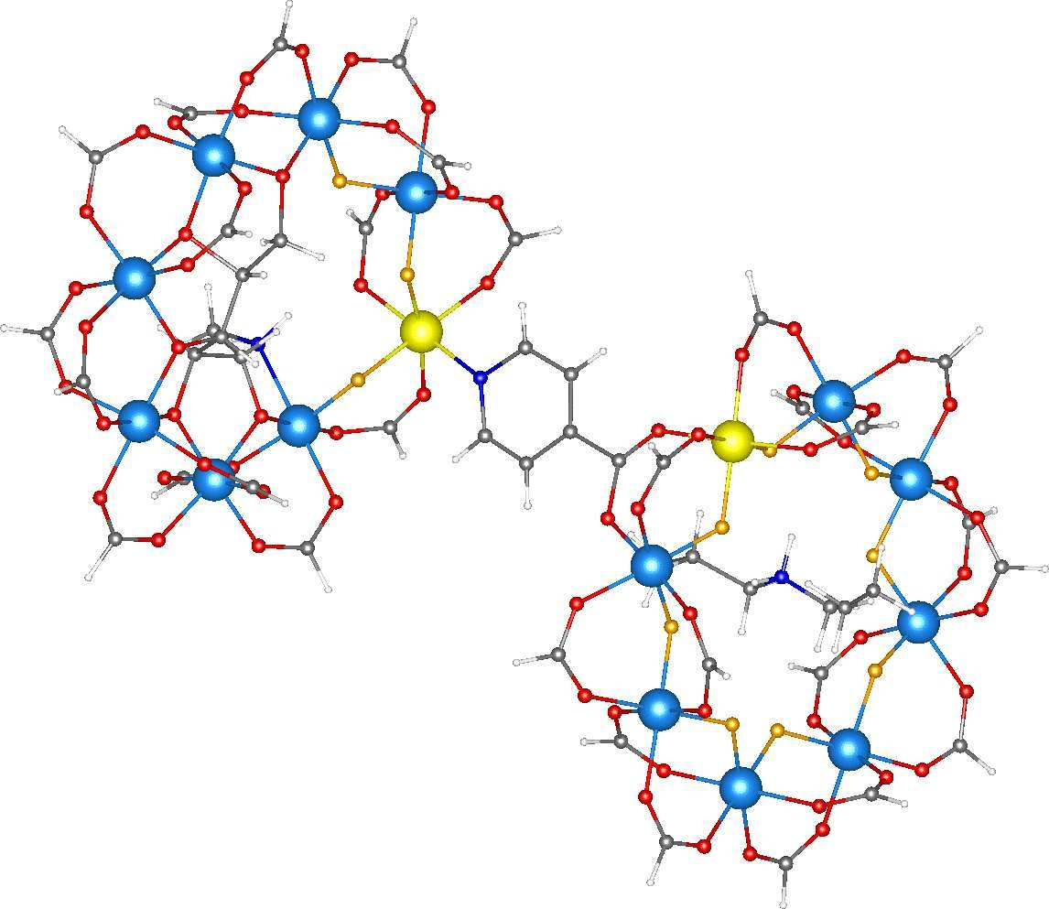
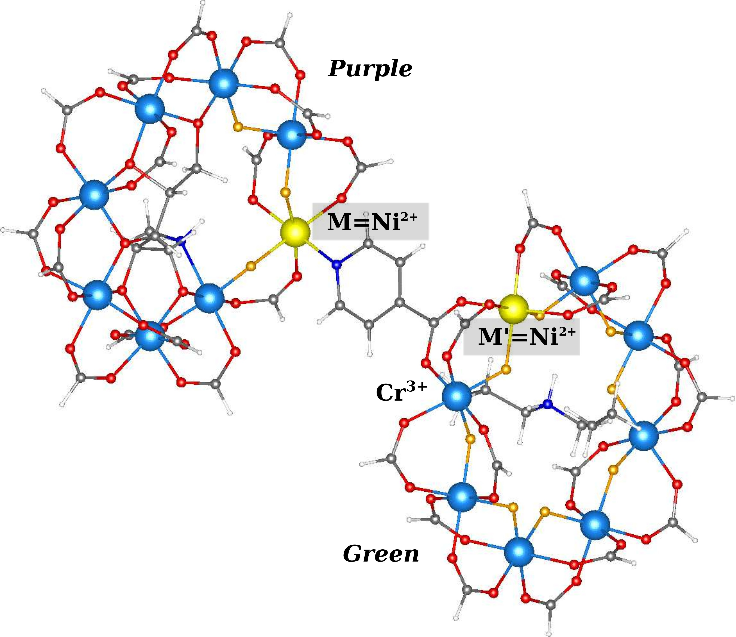
We have been exploring the idea that heterometallic rings can be used as qubits for quantum computing,¹ and have developed two families of heterometallic rings – one that can act as a Lewis base,² and hence be linked via simple Lewis acids such a single copper(II) site, and a second family that contains a single displaceable ligand and hence can act as a Lewis acid,³ and which can be linked by reaction with simple di-imines.⁴ Here we report the reaction between these two families of heterometallic rings.
The first family,⁵ which are green in colour, has the general formula [NEt₂H₂][Cr₇MF₈(O₂C^{t}Bu)₁₆]; here we discuss M = Ni, Mn or Zn. The metal sites form an octagon with each edge bridged by a fluoride and two pivalate ligands. Reaction of these compounds with iso-nicotinic acid allows the synthesis of rings that are substituted with a single iso-nicotinate: [NEt₂H₂][Cr₇MF₈(O₂C^{t}Bu)₁₅(O₂C-py)] M = Ni, 1; Mn, 2; Zn, 3. The relative rates of reaction of chromium(III) and the divalent metal⁶ means that the incoming nicotinate group must bind to an edge of the cage that contains the divalent metal.
The second family, which are purple in colour,³ has the general formula [Cr₇M’F₃(Etglu)(O₂CtBu)₁₅(OEt₂)], M’ = Ni, 4; Mn, 5; Zn, 6; H₅EtGlu = N-ethyl-D-glucamine. This family is made from reaction of hydrated chromium fluoride with pivalic acid in the presence of H₅EtGlu and a complex of the relevant divalent metal. Again, the eight metals form an octagon with the exterior of the octagon bridged by pivalate; in the centre of the ring is the penta-deprotonated EtGlu⁵⁻ ligand, with each alkoxide bridged two metal sites. The key feature of complexes 4 – 6 is the presence of a displaceable diethylether molecule bound to the divalent metal site.
If a functionalised green ring is mixed with a purple ring, dimers of formula: [NEt₂H₂][Cr₇MF₈(O₂C^{t}Bu)₁₅(O₂C-py) Cr₇M’F₃(Etglu)(O₂CtBu)₁₅]; we have made all nine members of the family, varying both M and M’. We can thus make a family of metal assemblies containing sixteen metals, with up to three different identities, knowing precisely where the different metals are positioned. The nine compounds are isostructural (Figure 1), with the individual rings unchanged from the reactants. The only change is that in place of the diethylether group in complexes 4-6, the divalent site is bound to a pyridine from iso-nicotinate

Figure 1. Crystallographic structure of complex 7 obtained from X-ray diffraction. The colours are as follow: Cr/large blue spheres, Ni/large yellow spheres, F/small orange spheres, C/small gray spheres, O/small red spheres, N/small dark blue spheres and H/small white spheres. H atoms have been inserted in place of each isobutyl -C(CH₃)₃ group.
The family of linked cages creates the opportunity to study the exchange interaction in these iso-structural complexes. The {Cr₇Ni} compounds 1 and 4 are the compounds regarded as possible qubits for quantum information processing as they have S = 1/2 spin ground states. Therefore here we report studies of compound 7, [NEt₂H₂][Cr₇NiF₈(O₂C^{t}Bu)₁₅(O₂C-py) Cr₇NiF₃(Etglu)(O₂CtBu)₁₅]; and show by a variety of methods that there is a weak but measurable interaction between the two rings in this molecular ensemble. As the structures of 1 and 4 are essentially replicated in 7 the only new parameters involved in fitting data involve the exchange interactions between the rings.
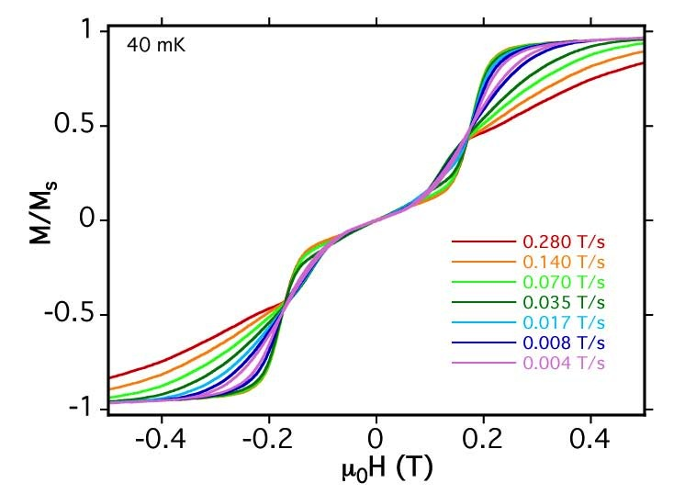
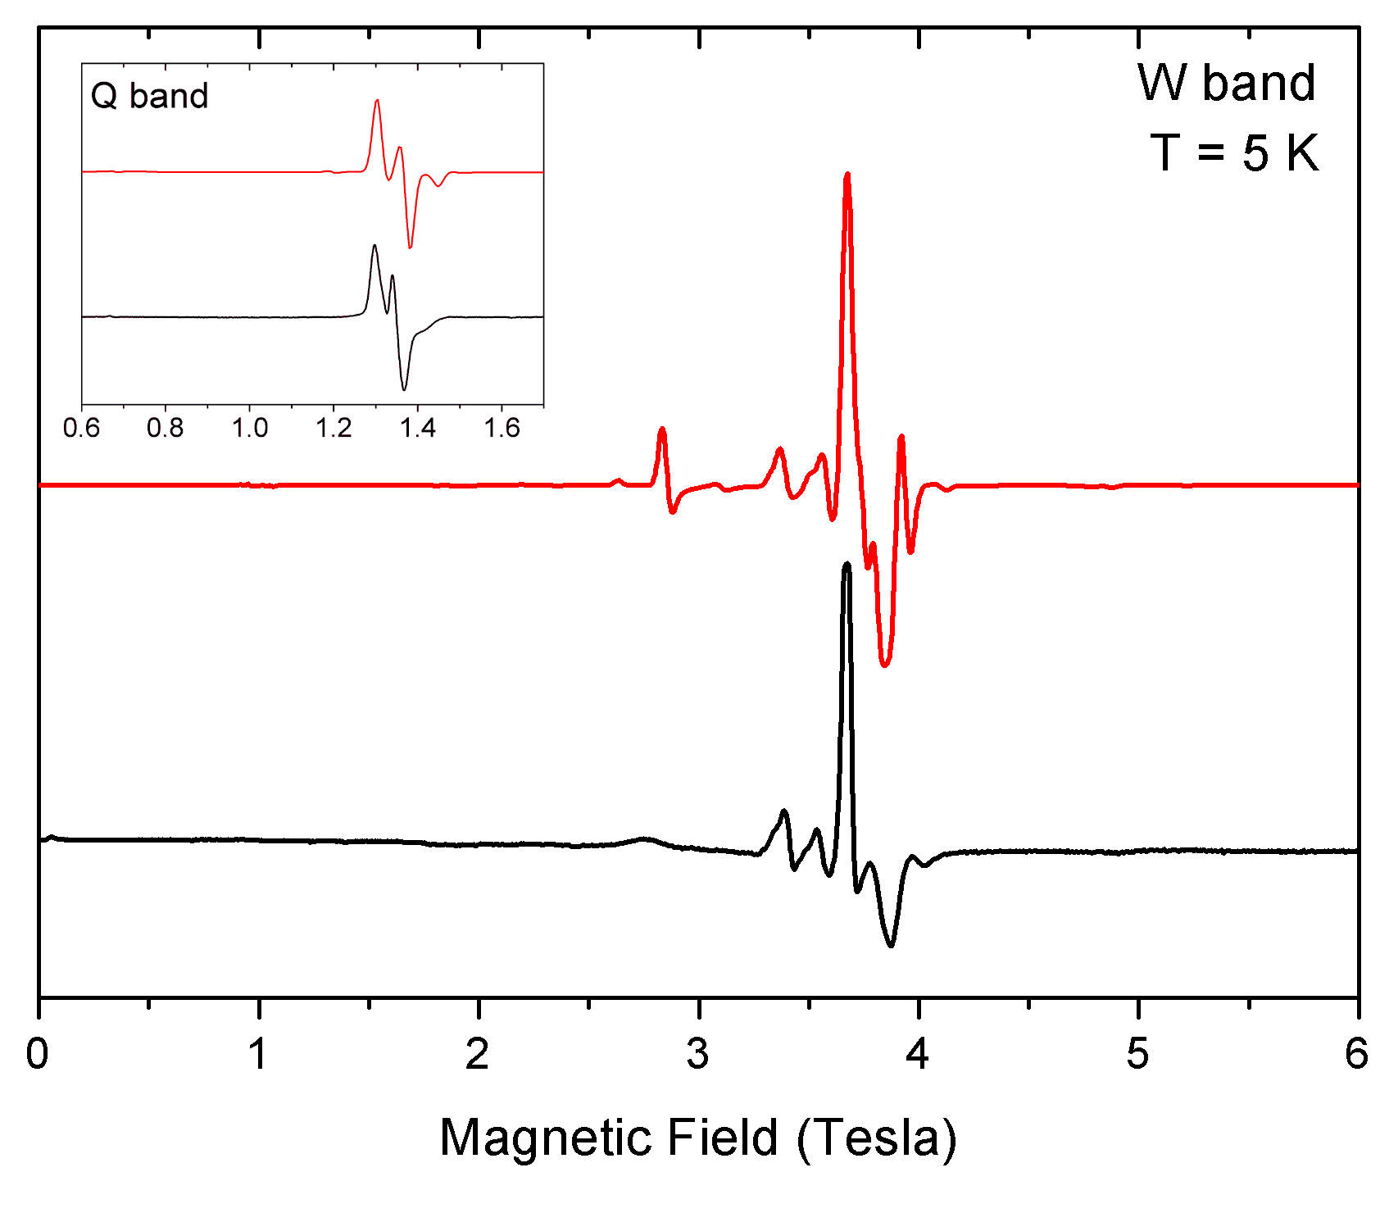
Magnetic susceptibility measurements of 7 between 2 K and 300 K show behaviour that is simply the sum of the two component rings (Figure S1). However, very low-temperature magnetization M(H) curves taken with a microSQUID clearly show a plateau around zero magnetic field H, which demonstrate the presence of an effective antiferromagnetic coupling between the two rings in their S =1/2 ground states, leading to a ground state singlet for the whole ensemble (Figure 2). Zero field specific heat (Figure 3) corroborates this finding showing an upturn below 1 K of an incipient Schottky anomaly due to the singlet-triplet splitting arising from the exchange coupling between the rings. Conversely, in a magnetic field the Schottky anomaly follows the behavior of isolated rings (not shown in figure 3)
Figure 2 Low temperature magnetization of 7. The plateau at zero field evidences the antiferromagnetic coupling between the two S = 1/2 rings.
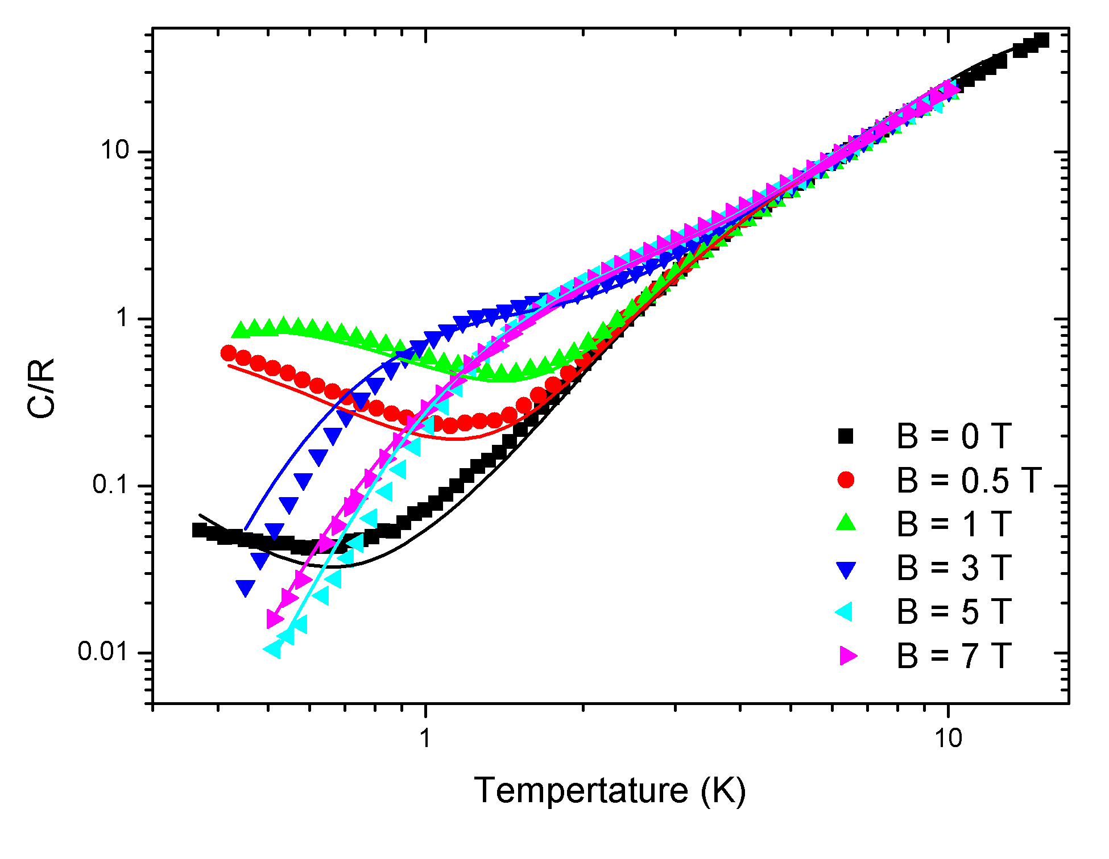
Figure 3 Temperature and magnetic field dependence of molar specific heat C (in gas constant R = 8.314J/mol K units) for 7 (markers). (Solid lines) best-fit of specific heat for 7, calculated as described in the text.
EPR spectroscopy is also sensitive to a weak exchange interaction.^{4b} For 7 the continuous wave EPR spectra at X-, Q- and W-band show that the two S = 1/2 centres are interacting. The resulting spectra are not a clearly resolved triplet, as we have previously found for exchange coupled heterometallic rings. However they are not interpretable as simply due to the sum of the spectra of 1 and 4. It is noticeable that the weak feature at ca. 2800 mT is much broader in the experimental spectrum than in the simulation.

Figure 4. W-band (93.95948 GHz) EPR spectrum of 7 (black) with simulation (red). The spectra were measured on powder samples at 5 K; the simulations are based on the parameters discussed in the text. The inset reports the measured and simulated Q-band (34.1585 GHz) spectrum.

These findings can be understood by describing the supramolecular dimer with a microscopic Hamiltonian H which is the sum of those of single purple and green rings (H_{p} and H_{g}), and of an exchange term between the two rings:
1) $H=H_{p}+ H_{g}+J_{Ni\left(p\right)-Cr\left(g\right)} S_{Ni\left(p\right)}∙S_{Cr\left(g\right)}$
$$+J_{Ni(p)-Ni(g)} S_{Ni(p)}∙S_{Ni\left(g\right)}$$

where the Hamiltonians describing single rings are³

$2)$$H_{p,g}= \sum_{i=1}^{6}{J∙S_{i}∙S_{i+1}}+J^{'}\left(S_{1}∙S_{Ni}+S_{7}∙S_{Ni}\right)+\sum_{i}{{d_{i} S}_{z_{i}}^{2}+}\sum_{i}{{e_{i} (S}_{x_{i}}^{2}-S_{y_{i}}^{2})+}μ_{B}B∙\sum_{i}{g_{i}∙ S_{i}}$.

The parameters $J$, $J^{'}$, $d_{i}$ and the g tensors for both single rings have been determined by thermodynamic and spectroscopic measurements³ and are given in Supplementary Table 1. These parameters were fixed in modelling the data of 7.
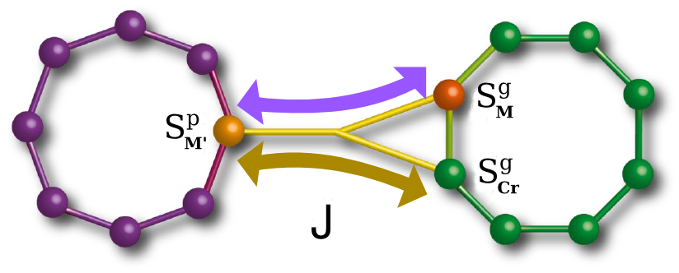
Figure 5 Sketch of the two possible magnetic interaction channels across the isonicotinate bridge.
To understand the coupling between the rings in 7 it is important to first realise that the exchange involves three metal centres (Figure 5). The Ni site in the purple ring is coupled to two metal centres in the green ring; one of these metal centres is a Cr and the other a Ni, and they are AF-coupled to one another. Therefore the Ni site in the purple ring will be aligned parallel to one of these two spins and anti-parallel to the other. As the overall interaction is AF (with 7 having an S = 0 ground state) this means there is an AF Ni…Ni interaction and a ferromagnetic Ni-Cr interaction. The experimental data can be simulated using ${J_{Ni\left(p\right)-Ni\left(g\right)}=-J}_{Ni\left(p\right)-Cr\left(g\right)}=$ 0.17 K. Transitions involving excited states of the single rings (with S > 1/2) contribute to the W-band EPR spectrum. In particular, the observed transition at about 2.8 T involves the S = 3/2 multiplets. This could be at the origin of the observed broadening of the line.
The magnetic-field dependence of the low-lying energy levels of 7 resulting from this model is reported in Figure 6 for B perpendicular to the rings. The position of the singlet-triplet crossing is consistent with the main step in the low-temperature magnetization curves.
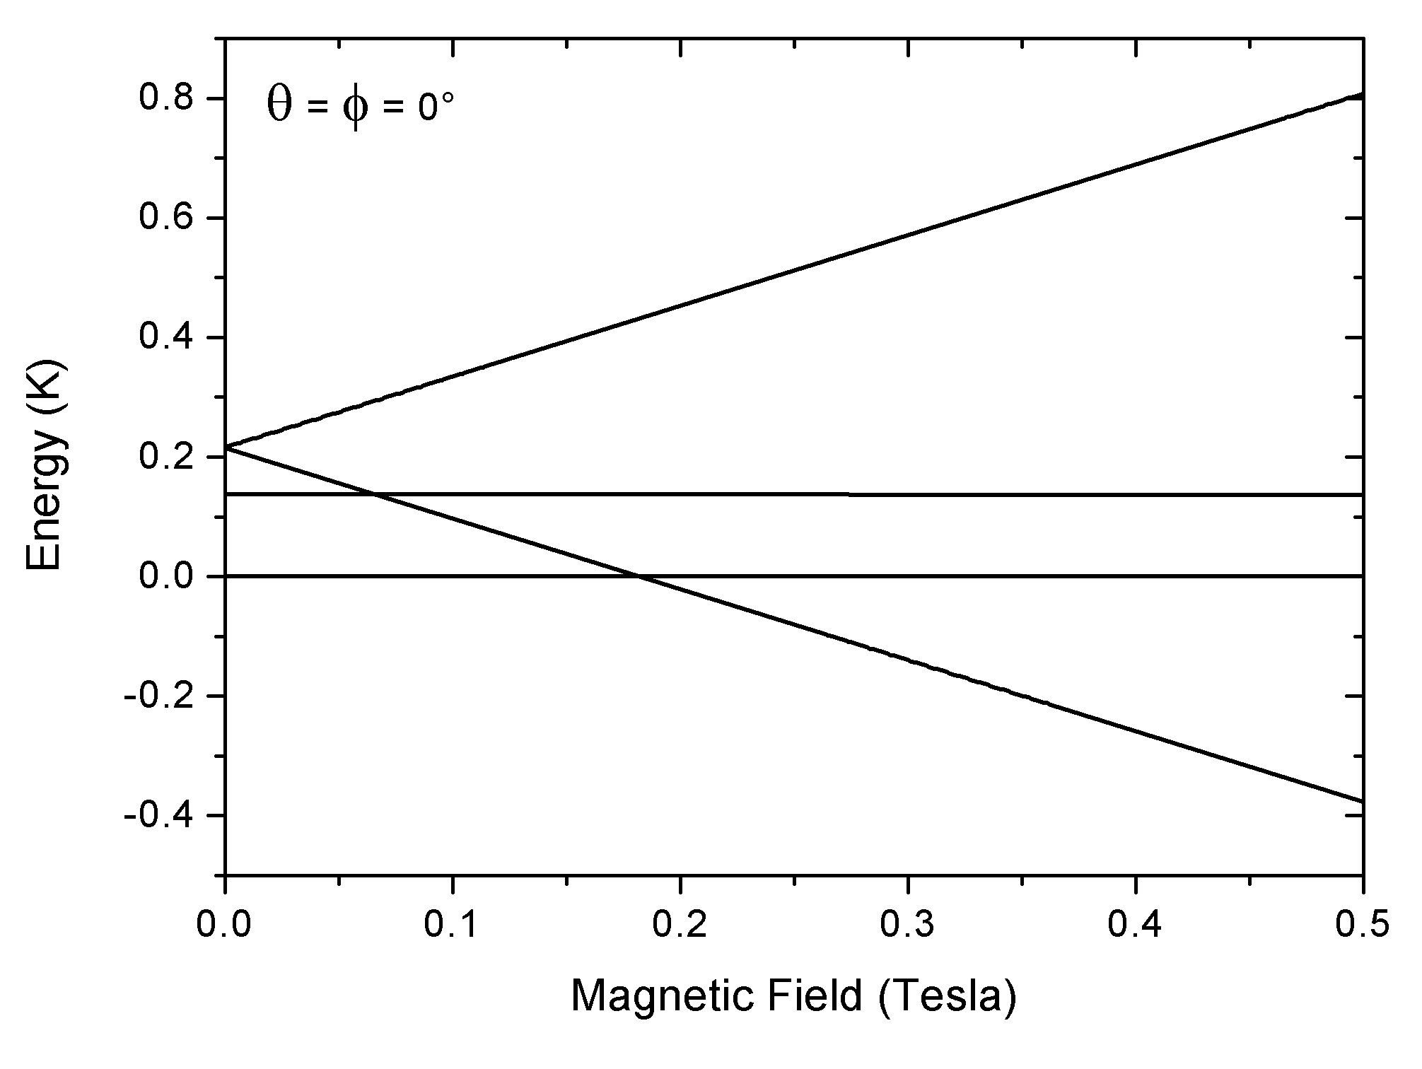
Figure 6. Calculated magnetic field dependence of the lowest lying energy levels of 7, with B perpendicular to the rings.

The microscopic mechanism behind the inter-ring exchange interaction discussed above is particularly interesting, because the bridging between the green and purple rings does not involve one superexchange path (see the sketch in Fig. 5). The iso-nicotinate ligand binds to a Cr and Ni at the green ring, but only to a Ni site at the purple ring. Therefore to understand the magnetic exchange we need to consider both a Cr(g)…Ni(p) and Ni(g)…Ni(p) exchange. The balance between these two exchange interactions control the low temperature magnetism.
To understand these interactions we have evaluated the magnetic coupling between the magnetic ions belonging to different rings through the organic linker by DFT calculations. The results have been obtained employing the NWChem quantum chemistry package [1]. In order to account for the electronic correlation, we used the B3LYP hybrid exchange-correlation functional [2]. Broken-symmetry (BS) magnetic configurations were obtained with the help of the constrained-DFT method [3, 4].
We follow the procedure described in Ref. [5], where total energies of different broken symmetry (BS) states are mapped onto a microscopic spin model Hamiltonian, which contains only isotropic Heisenberg exchange terms (dipolar interactions are tiny and spin-orbit coupling is not included in the calculation) [6]. H_{ex} turns out to be the sum of three terms.

The problem can be further simplified, considering that intra-ring interactions are one order of magnitude larger than inter-ring ones [7, 8, 9, 10, 11], which implies that excited states probed in low-temperature experiments are associated to variations of the total spin of the dimer, keeping frozen the molecular spins in each ring. If we consider BS states where the antiferromagnetic intra-ring coupling is maintained, total energies of the BS states could be rewritten as (THE FOLLOWING EQUATION MUST BE REWRITTEN WITH THE SAME METHOD AS PREVIOUSLY, BUT I DO NOT KNOW HOW TO DO IT)

where E^{intra} is a constant energy term, Js are inter-ring exchange parameters, and the various s_{z} are the spin moments of the three frontier ions (see Figure 1). According to eq.3, if we retain the antiferromagnetic coupling between the spins in each of the ring, and flip coherently all the spins in one of the ring, we could obtain the total energies of only two BS states, characterized by having the total spins of the two rings coupled either ferro- (FM) or antiferromagnetic (AFM) to each other.
Contrary to the purple-purple dimer case [5], we have here two unknown inter-ring exchange constants, J_{Ni(p)−Ni(g)} and J_{Ni(p)−Cr(g),} thus we have more variables than equations. To overcome this problem, we make the assumption that the two microscopic interactions Ni(p)−Ni(g) and Ni(p)−Cr(g) could be considered, in first approximation, independent from each other, i. e. if the Ni(g) is substituted with a different divalent ion, the interaction between Ni(p) and Cr(g) remains unaltered. Substituting the Ni on the green ring with a Zn (s = 0) non magnetic ion, we can thus turn off one of the interaction channel, and obtain the Ni(p)−Cr(g) exchange constant. Once J_{Ni(p)−Cr(g)} is calculated, we determine the J_{Ni(p)−Ni(g)} exchange coupling, from the FM and AFM BS states of complex 7. The total energy differences between AFM and FM states are respectively −2.1 and −3.1 K, showing that low spin states are energetically favored with respect to the high spin ones. This is in agreement with the experimental finding that in complex 7 the magnetic ground state is a singlet. The inter-ring exchange parameters found are J_{Ni(p)−Cr(g)} = −0.7 K and J_{Ni(p)−Ni(g)} = 0.6 K. Interestingly, they are not always antiferromagnetic (J > 0) as it happens in the purple-purple dimers [5] but they can be ferromagnetic as well.
In order to get more insight on the interaction channel we show in Fig. 7 three-dimensional contour plot of the spin polarization density, zooming in the interaction region across the nicotinate bridge. From the accurate analysis of the spin-polarized electron density in the carboxylate group belonging to the iso-nicotinate bridge in Figures 7, a sort of competition emerges between the two metallic ions placed on the green ring of the dimer: the atom with the largest absolute value of the spin imposes his own spin alternation along the iso -nicotinate bridge up to the first C atom of the pyridine ring. Such spin polarization must match the one across the pyridine ring, which in turn is determined by the sign of the spin moment of the divalent ion, in this case Ni, of the purple ring [5]. In complex 7, the polarization induced on the nicotinate bridge due to Cr(g) overrides the one of Ni(g), this behavior being also reflected by the fact that J_{Ni(p)−Cr(g)} is larger than J_{Ni(p)−Ni(g)}.

Summarizing, ab-initio calculations point to two microscopic inter-ring exchange interactions having the same magnitude but opposite sign, an antiferromagnetic Ni-Ni coupling and a ferromagnetic Ni-Cr one. These results are therefore fully consistent with the miscroscopic spin Hamiltonian used to interpret experimental results. The discrepancy in the magnitude of the exchange constants is within the uncertainty in the determination of the intermolecular exchange constants and consistent with what is typically found using the B3LYP functional to account for electronic correlations [5,7].

Figure 7 Spin-polarization density in complex 7 in the AFM configuration, zoomed in the region of the nicotinate bridge, for isovalues of + (cyan) and − (red) 0.0005 electrons/a.u.³

We are grateful to the EPSRC (UK) for funding; M. Albring is a member of the Centre for Doctoral Training NoWNANO. and the Royal Society for a Wolfson Merit Award (to REPW). We acknowledge financial support also from the FIRB Project No. RBFR12RPD1 of the Italian Ministry of Education and Research. We acknowledge the CINECA center for granting the high-performance computing resources.

Notes and references
ª School of Chemistry , The University of Manchester, Oxford Road. M13 9PL, Manchester (UK).
^{b} Dipartimento di Fisica, Informatica e Matematica. Università di Modena e Reggio Emilia, via Campi 213/a, 41125 Modena, Italy.
^{c}The Photon Science Institute, The University of Manchester, Oxford Road, Manchester M13 9PL (UK). Fax: (+44)161-275-4616; E-mail: richard.winpenny@manchester.ac.uk
^{d}CNR-NANO-S3 via Campi 213/a, 41100 Modena, Italy.
^{ξ}current address: Instituto de Ciencia de Materiales de Aragón, Calle Pedro Cerbuna 12, 50009, Zaragoza, Spain.
^{e}Dipartimento di Fisica e Scienze della Terra, Università di Parma, Parco Area delle Scienze 7/A, 43124 Parma, Italy.
† Electronic Supplementary Information (ESI) available: experimental details and selected bond lengths and angles for 1, 2, 3 and 5. See DOI: 10.1039/b000000x/

- (a) F. Troiani, A. Ghirri, M. Affronte, S. Carretta, P. Santini, G. Amoretti, S. Piligkos, G. Timco and R. E. P. Winpenny, Phys. Rev. Lett. 2005, 94, 207208; (b) A. Ardavan, O. Rival, J. J. L. Morton, S. J. Blundell, A. M. Tyryshkin, G. A. Timco and R. E. P. Winpenny, Phys. Rev. Lett. 2007, 98, 057201.
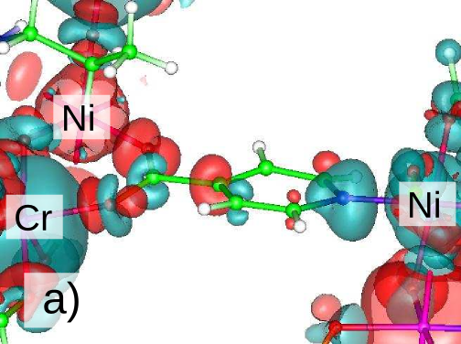
- (a) G. A. Timco, S. Carretta, F. Troiani, F. Tuna, R. G. Pritchard, E. J. L. McInnes, A. Ghirri, A. Candini, P. Santini, G. Amoretti, M. Affronte and R. E. P. Winpenny, Nature Nanotechnology, 2009, 4, 173; (b) G. F. S. Whitehead, F. Moro, G. A. Timco, W. Wernsdorfer, S. J. Teat and R. E. P. Winpenny, Angew. Chem. Int. Ed., 2013, 52, 9932.
- E. Garlatti, M. A. Albring, M. L. Baker, R. J. Docherty, V. Garcia Sakai, H. Mutka, T. Guidi, G. F. S. Whitehead, R. G. Pritchard, G. A. Timco, F. Tuna, G. Amoretti, S. Carretta, P. Santini, G. Lorusso, M. Affronte, E. J. L. McInnes, D. Collison and R. E. P. Winpenny, J. Amer. Chem. Soc., 2014, 136, 9763.
- (a) A. Candini, G. Lorusso, F. Troiani, A. Ghirri, S. Carretta, P. Santini, G. Amoretti, C. Muryn, F. Tuna, G. Timco, E. J. L. McInnes, R. E. P. Winpenny, W. Wernsdorfer and M. Affronte, Phys. Rev. Lett. 2010, 104, 037203; (b) T. B. Faust, V. Bellini, A. Candini, S. Carretta, G. Lorusso, D. R. Allan, L. Carthy, D. Collison, R. J. Docherty, J. Kenyon, J. Machin, E. J. L. McInnes, C. A. Muryn, H. Nowell, R. G. Pritchard, S. J. Teat, G. A. Timco, F. Tuna, G. F. S. Whitehead, W. Wernsdorfer, M. Affronte and R. E. P. Winpenny, Chem. Eur. J. 2011, 17, 14020; (c) T. B. Faust, F. Tuna, G. A. Timco, M. Affronte, V. Bellini, W. Wernsdorfer and R. E. P. Winpenny, Dalton Trans., 2012, 41, 13626.
- S. Piligkos, H. Weihe, E. Bill, F. Neese, H. El Mkami, G. M. Smith, D. Collison, G. Rajaraman, G. A. Timco, R. E. P. Winpenny and E. J. L. McInnes, Chem. Eur. J. 2009, 15, 3152.
- S.F. Lincoln, Helv. Chim. Acta, 2005, 88, 523.

[1] M. Valiev, E. J. Bylaska, N. Govind, K. Kowalski, T. P. Straatsma, H. J. J. Van Dam, D. Wang, J. Nieplocha, E. Apra, T. L. Windus, and W. A. de Jong, “NWChem: A comprehensive and scalable open-source solution for large scale molecular simulations,” Comp. Phys. Commun., vol. 181, no. 9, pp. 1477–1489, 2010.
[2] A. D. Becke, “Density-functional thermochemistry. III. the role of exact exchange,” J. Chem. Phys. , vol. 98, no. 7, pp. 5648–5652, 1993.
[3] Q. Wu and T. Van Voorhis, “Direct optimization method to study constrained systems within density-functional theory,” Phys. Rev. A, vol. 72, p. 024502, Aug 2005.
[4] I. Rudra, Q. Wu, and T. Van Voorhis, “Accurate magnetic exchange couplings in transition-metal complexes from constrained density- functional theory,” J. Chem. Phys. , vol. 124, p. 024103, Jan. 2006.
[5] V. Bellini, G. Lorusso, A. Candini, W. Wernsdorfer, T. B. Faust, G. A. Timco, R. E. P. Winpenny, and M. Affronte, “Propagation of spin in- formation at the supramolecular scale through heteroaromatic linkers,” Phys. Rev. Lett. , vol. 106, p. 227205, Jun 2011.
[6] S. Blundell, Magnetism in Condensed Matter. Oxford University Press, 2001.
[7] V. Bellini and M. Affronte, “A density-functional study of heterometal- lic Cr-based molecular rings,” J. Phys. Chem. B, vol. 114, no. 46, pp. 14797–14806, 2010.
[8] R. Caciuffo, T. Guidi, G. Amoretti, S. Carretta, E. Liviotti, P. Santini, C. Mondelli, G. Timco, C. A. Muryn, and R. E. P. Winpenny, “Spin dynamics of heterometallic Cr7M wheels (M = Mn, Zn, Ni) probed by inelastic neutron scattering,” Phys. Rev. B, vol. 71, p. 174407, May 2005.
[9] M. Allalen and J. Schnack, “Theoretical estimates for proton-NMR spinlattice relaxation rates of heterometallic spin rings,” J. Magn. Magn. Materials, vol. 302, no. 1, pp. 206–210, 2006.
[10] H. Amiri, M. Mariani, A. Lascialfari, F. Borsa, G. A. Timco, F. Tuna, and R. E. P. Winpenny, “Magnetic properties and spin dynamics in the Cr7Fe nanomagnet: A heterometallic antiferromagnetic molecular ring,” Phys. Rev. B, vol. 81, p. 104408, Mar 2010.
[11] L. Engelhardt, C. Muryn, R. Pritchard, G. Timco, F. Tuna, and R. Winpenny, “Octa-, deca-, trideca-, and tetradecanuclear het- erometallic cyclic chromiumcopper cages,” Angew. Chem. Int. Ed., vol. 47, no. 5, pp. 924–927, 2008.

