Geochemical and mineralogical characterization of a megacryst of apatite from the Tertiary volcanism of the Veneto Volcanic Province, Italy.
Cipriani A*., Giovanardi T., Mazzucchelli M.*, Lugli F., Sforna. M.-C., Gualtieri A.F., Di Giuseppe D., Brunelli D.
Corresponding authors *

Abstract
We present mineralogical and chemical data of a megacryst of apatite (MT1) sampled in Tertiary volcanics of the Veneto Volcanic Province from the Western Lessini Mountain range (Veneto, Northern Italy).
The MT1 apatite is a unique cm-sized specimen recovered from altered volcanics. The crystal was identified and characterized by SEM, XRD, Raman spectroscopy and electron microprobe analyses.
Major and trace elements of the primary mineralogy are consistent with crystallization from a nelsonitic melt or alkaline melt metasomatized by a carbonated-rich fluid. The Sr and Nd isotopic composition of the apatite fits within the field of variability of lavas and xenoliths from the VVP. Our data are in agreement with a recent geodynamic model for the hybridization of the VVP mantle that calls upon breakdown of carbonates within the subducting oceanic Thetis slab.
A cronstedtite, chabazite, calcite mineral assemblage, associated with reaction rims of amphibole and F-rich secondary apatite within the primary apatite originated from low temperature hydrothermal alteration of the volcanics a widespread occurrence in VVP volcanics, except for cronstedtite which is the first appearance in the area.

1. Introduction
Apatite is usually a minor but ubiquitous component in magmatic rocks and precipitates usually very early from carbonatitic and silicatic melts due to the low solubility of phosphorus (Tollari et al 2006). In addition, apatite accommodates a plethora of components and elements in its mineral structure such as magmatic water, halogens, S, C, and trace elements including Sr, U, Th, and the rare earth elements (Piccoli and Candela, 2002). It is therefore a powerful mineral to study the evolution of magmatic processes and the geochemical budget of the source, holding clues on the volatile inventory of partial melts and mantle. Apatites are also particularly interesting and valuable minerals because of their role as the main repository of the element phosphorous and are pillars to the global phosphorous cycle being the most abundant phosphate mineral.
In geological terms, apatite can form in igneous as well as in metamorphic, sedimentary and hydrothermal environments. Differences in chemical composition, texture and mineral assemblage in the host rock generally help in distinguishing their genetic origin. Hydrothermal apatite is for example mostly depleted in Sr, REE (Rare Earth Elements), Mn and Th but enriched in F compared to igneous apatite (Chakhmouradian et al., 2017).
In the igneous realm, one open question is the origin of the volatile- P- rich melt from which apatite generally separates. It has been shown that apatite crystallizes from magmas whose composition ranges from silicatic to carbonatitic as a high-pressure magmatic crystallization product (Green and Watson 1982) but it can also fractionate from melts of mantle parcels that have been metasomatized (O'Reilly and Griffin, 2000).
We report on the discovery of a centimeter-sized megacryst of apatite (MT1), in altered Tertiary volcanics of the Veneto Volcanic Province (VVP) outcropping in the Lessini Mountains (Italy). The VVP is a well-studied volcanic province (Brombin et al. 2019, and references therein) and finding of megacrysts of mineral phases other than apatite in the VVP is not uncommon (Braga et al., 2006; Morten et al., 1993 and references therein). Megacrysts hold important clues depending on their origin as either high pressure phases formed at mantle conditions or as fragments of pegmatitic veins (Irving, 1980). The genesis of cm-sized clinopyroxenes, amphiboles, spinels and feldspars found in VVP basanites has been attributed to the crystallization at lower crust and upper mantle conditions of melts different from those that crystallized the host VVP rocks (Morten et al., 1993). Therefore, those megacrysts represent xenocrysts in the present-day VVP host rocks, which crystallized at depth, were picked up by the ascending magmas and transported to the surface without re-equilibration with the host magma (Morten et al., 1993). Additionally, Braga et al (2006) reported an exceptional occurrence of a mica megacryst associated with a mm-long apatite included in an alkaline basic VVP dyke. They show that the mica megacryst crystallized in the mantle, at depths consistent with the spinel-facies stability field, from a metasomatized melt after early fractionation of apatite.
Up until now, the mm-long apatite of Braga et al (2006) was the largest and to our knowledge the only one apatite specimen recovered from the VVP. Due to the size and unicity of the MT1 specimen, we performed a comprehensive mineralogical and geochemical investigation of the apatite specimen and report in this paper on these results, in combination with previous literature data from the VVP area. The role of apatite crystallization in the VVP lavas is examined with particular emphasis on trace element distribution in alkaline rocks.

2. Geological background
The MT1 apatite megacryst was recovered from completely altered Tertiary volcanics of the so-called Veneto Volcanic Province (VVP) in the western portion of the Lessini Mountains north of Verona (Northern Italy, Fig. 1). These volcanics were formed in a submarine environment and are represented by hyaloclastite and unconsolidated volcanoclastic meters to decameters size deposits, locally appearing as diatremes, suggesting the occurrence of shallow submarine eruptive systems. The outcrop where MT1 was extracted is exposed on the western flank of the Monte Tesoro, along the provincial road SP12 between the locality of Giare and the village of Corrubio (Fig. 1). The megacryst was recovered from brown-reddish partially unconsolidated hyaloclastite volcanics about two meters above their contact with older Cretaceous layers of the Scaglia Rossa Formation (Fig. 1). Upon the discovery of the Mt1 apatite specimen a large search of the area was launched to try to recover other specimens. Yet, this is the only apatite recovery from the Monte Tesoro volcanics.
The VVP is an extension-related magmatic province that developed between the late Paleocene and the early Miocene in response to the collisional convergence of the European and African plates during the Alpine orogenesis (De Vecchi & Sedea, 1995; Zampieri, 1995). The VVP covers the eastern-central sector of the south Alpine domain (northeastern Italy), and consists of tuffs, pillow lavas, lava flows and eruptive necks with compositions spanning from nephelinic to tholeiitic terms with alkaline/transitional affinities frequently hosting mantle xenoliths and localized acid (latitic, trachytic and rhyolitic terms) volcanic and subvolcanic bodies (De Vecchi & Sedea, 1974; Morten, 1987; Bonadiman et al. 2001; Macera et al., 2003; Braga et al., 2006; Cannatelli 2012; Brombin et al., 2016; Brombin et al 2019).
The VVP comprises five main volcanic districts: Val d’Adige, Lessini Mountains, Marosticano, Berici Hills and Euganean Hills (Beccaluva et al., 2007). According to several authors, the first volcanic activity developed during the Paleocene-Eocene in the western-most VVP provinces, i.e. the Val d’Adige and the Lessini Mts. areas (Brombin et al., 2019 and references therein). Over time, this magmatism migrated south-eastwards towards the central-Western Lessini, the Berici Hills and the Euganean Hills, changing geochemical affinity from mainly alkaline and basanitic extrusions to more transitional basalts.
A recent review of the geodynamic processes behind the development and evolution of the VVP (Brombin et al 2019) has put forward a scenario in which the initial rollback of the European plate created a steepening of the slab and the consequent formation of a poloidal mantle flow, which caused the breakdown of carbonates within the subducting Tethys oceanic slab. These components might have produced carbonated melts and be responsible for the metasomatization of the mantle below the VVP. Following the metasomatic event, the upwelling poloidal mantle flow created also the conditions for the extensional deformation within the Adria plate that has generated the VVP.

3. Analytical Methods
The MT1 apatite specimen is a vitreous black, 2.4 cm long and 1.3 cm wide, single crystal (Fig. 2A). The crystal appears sub-idiomorphic with a dypyramidal habit and a sub-hexagonal section.
The specimen as a whole was repeatedly washed with milliQ in an ultrasonic bath before being cut with a precision saw. A 2 mm thick polished slice of sample was glued to a petrographic thin section and used for SEM characterization, Raman and in situ major and trace element analyses. A portion of the sample was crushed and 50 mg of sample were powdered with an agate mortar and pestle for XRD and isotope analyses.
A detailed SEM investigation of the Mt1 specimen was carried out using the JEOL JSM-6010LA InTouchScope Scanning Electron Microscope (SEM) housed at the Dipartimento di Scienze Chimiche e Geologiche of the Università di Modena e Reggio Emilia after carbon-coating of the sample. Operating conditions for EDS analyses were a 20 kV accelerating potential and a 4 to 15 nA beam current. Backscatter SEM images were obtained by recombining the single major element density in backscattered and secondary electron modes.
The XRPD pattern of specimen Mt1 was collected using a conventional Bragg–Brentano diffractometer (model Philips PW-1729), with θ–2θ geometry, CuKα radiation, 40 kV, 30 mA and a gas proportional detector. The sample powders were loaded on an aluminum sample-holder using the side loading method. Data were collected in continuous mode with a ½° fixed divergence slit on the incident beam, and a receiving slit of 0.2 mm coupled with an antiscatter slit of ½° mounted on the diffracted beam. An integrated step-scan of the detector of 0.02 °2θ was used with a time of 15 s/step from 3 to 120 °2θ. The Rietveld quantitative phase analysis of the sample was performed using GSAS (Larson & Von Dreele, 1999) and its graphical interface EXPGUI (Toby, 2001). The starting structure model of hydroxyapatite, which perfectly fits the data, was taken from Hughes et al. (1989). In GSAS, the background was successfully fit with a Chebyshev function with 12 coefficients. The peak profiles were modelled using a pseudo-Voigt function with one Gaussian and one Lorentzian coefficient. The lattice constants, the phase fraction and coefficients corresponding to sample displacement and asymmetry were also refined. The cut-off value for the calculation of the peak profiles was 0.1%.
Micro-Raman analyses were performed on the 2-mm thick section using a Jobin Yvon LabRAM™ microspectrometer housed at the Centro Interdipartimentale Grandi Strumenti of the University of Modena and Reggio Emilia (CIGS-UNIMORE) using the 632.81 nm wavelength of a20mW He-Ne laser focused through a Olympus BX40 microscope with × 100 objective (Numerical Aperture (NA) = 0.9). Laser excitation was adjusted to an on sample intensity inferior to 2mW with integration time of 6 × 30 s. This configuration yielded a planar resolution close to 1 μm. Acquisitions were obtained with a 1800 l/mm grating illuminating a Pelletier-cooled 1024 × 256 pixel CCD array detector. Punctual analyses were carried out in static mode with a spectral detection range of 200–1600 cm⁻¹. Beam centering and Raman spectra calibration were performed daily on a quartz crystal with a characteristic SiO₂ Raman band at 463.5 cm⁻¹. Data were processed with Renishaw WiRE 3.3™ software. Baseline subtraction was performed due to high fluorescence with a third order polynomial fit generated using the ‘explicit X position’ mode of Wire 3.3 software.
Major elements of the apatite specimen were analyzed with a with a Cameca-Camebax at the CAMPARIS micro analyses centre (Paris, Sorbonne Université) with 15 KV accelerating voltage and 20 nA beam current. A range of natural and synthetic standards was used and matrix correction carried out according to Bence & Albee (1968). Analytical procedures and parameters are reported in Brunelli et al., 2020 and Seyler and Brunelli, 2018.
Trace elements were measured in situ by Laser ablation LA-ICP-MS (ICP-MS XSeries^{II} - Thermo Fisher Scientific coupled to Laser Ablation UP 213 - New Wave Research) at the CIGS-UNIMORE. The laser spot size was 40 μm, a repetition rate of 10 Hz and a fluence of 10 J/cm2 were used. The ICP- MS was tuned using NIST610, NIST612 and NIST614 glass reference materials to optimize the signal intensity and stability, checking 139La, 238U and the 238U/232Th ratio. Analyses were recalculated using the PlasmaLab software and using the NIST reference materials as external standards and 44Ca as internal standard according to the procedure of Giovanardi et al. (2018).
Sr and Nd isotopes were separated by cation-exchange chromatography from 10 mg of sample powder. We carefully handpicked the chips of apatite in order to avoid any secondary mineralization before producing the powder for isotope analyses. Sr extraction procedure has been described in previous studies (Lugli et al., 2017a). For MC-ICPMS isotopic determinations, three different batches of 5 mg of MT1 apatite powder were leached in 8N HNO₃ and digested in a HNO3+ HF mixture in a Teflon vessel. Sr was separated using Eichrom Sr resin and Nd was separated in a two-column procedure using Eichrom TRU-spec resin to separate the rare-earth elements, followed by Eichrom LN-spec resin to sequentially separate the LREE. Nd extraction has been completed by a two stage column separation scheme. The first column filled with TRU spec resin separates the rare earth element from the matrix. Subsequently, Nd is separated from the other REE on the second column using Ln specific resin.
Isotopes were measured on a MC–ICPMS Neptune, housed at the CIGS-UNIMORE. The mass fractionation corrections were based on ⁸⁶Sr/⁸⁸Sr = 0.1194 and ¹⁴⁶Nd/¹⁴⁴Nd = 0.7219. During the analysis of MT1, repeated analyses yielded a ⁸⁷Sr/⁸⁶Sr ratio of 0.710270 ± 0.000003 for the NBS-987 Sr standard (2σ external reproducibility, n=3) and a ¹⁴³Nd/¹⁴⁴Nd ratio of 0.512064 ± 0.000007 for the JNdi-1 (2σ external reproducibility, n=3). Ratios were reported to the accepted values of 0.710248 (McArthur et al., 2001) and 0.512115 (Tanaka et al., 2000) for the NBS-987 and JNdi-1 standards. Total blanks for Sr and Nd did not exceed 100pg.
Given the presence of one identified trail of clinopyroxene and of an area with pervasive secondary alteration mineral assemblages we performed in situ Sr analyses to double check if any secondary mineralization might have contributed to the isotopic signature of the powdered sample. In situ Sr isotope analyses were determined at the CIGS laboratories using a double focusing MC–ICP-MS with a forward Nier–Johnson geometry (Thermo Fisher Scientific, Neptune™), coupled to a 213 nm Nd:YAG laser ablation system (New Wave Research™) according to the procedure described by Lugli et al. (2017a). In situ laser data were collected as a spot analysis and as a line scan.
Spot analyses collected blocks of 250 cycles, which comprises laser warm-up and ca. 50-80 cycles of analysis and washout. Integration time was settled at 0.5 s, the laser spot at 55 μm and the fluence at of ~10 J/cm2. To achieve a better signal stability, a low laser frequency (~10 Hz) with a He flux of ~0.5 L/min was used. The surface of the crystal was pre-ablated before each analysis using a spot-size of 60 μm. Collected masses are the same as in the solution analyses. The instrument was tuned for maximum sensitivity on 88 mass. Doubly-charged Yb interferences were monitored collecting masses 85.5 and 86.5. Background Kr was corrected measuring 60 s of gas blank with the laser off. After background subtraction, the remaining signal on mass 82 was used to check the formation of Ca dimers and argides. Interference-free ⁸⁵Rb signal was used to calculate the ⁸⁷Rb contribution on mass 87 using the natural ⁸⁷Rb/⁸⁵Rb ratio corrected for instrumental mass bias. An in-house reference material (modern marine shell) and international reference material JCt-1 were used to monitoring the accuracy of the ⁸⁷Sr/⁸⁶Sr ratio. The Sr isotopic ratio of reference materials are of 0.709166±0.000039 (2σ; n=4), in agreement with modern seawater (0.70917) and of 0.709151±0.000013 (2σ; n=4), in agreement with JCt-1 values. Data were corrected with the V3 version of the SrDR spreadsheet according to their high REE content (Lugli et al., 2020).

4. Analytical Results
4.1 SEM
A SEM investigation of the MT1 specimen revealed that the cm sized slightly fractured crystal is Cl-F apatite, with a small portion along one of the rims, crossed by a thin network of cavities/veinlets filled with secondary mineral phases (Figs 2 and 3). This area occupies a few mm and the cavities/veinlets are smaller than 1 mm in size. Within this area, we have identified different mineral assemblages possibly formed upon reactions of infiltrating late fluids/melts with the primary apatite.
We first identified a 0.5 cm long trail of clinopyroxene characterized by a thin rim of F-rich apatite at the contact with the primary apatite (Fig2C). Clinopyroxenes are up to 100 µm and exhibit a subhedral shape. Thinner veinlets connected to the clinopyroxene trail through a secondary network of veins consist only of F-rich apatite with or without a central fracture (Figs 2B and 2D). We refer to this clinopyroxene as a magmatic clinopyroxene but crystallized after the primary apatite. We refer to the F-rich apatite as secondary apatite and its origin will be discussed as secondary mineralization.
Another set of veinlets/patches is filled with sub-spherical crystals of zeolites growing inwards, away from the primary apatite. The contact between the primary apatite and the zeolite is composed of a rim of amphibole (Figs 3A and 3B). In certain instances, instead of amphibole, the rim between the zeolite and the primary apatite is made of F-rich apatite chemically similar to the F-rich apatite rim surrounding the contact of the clinopyroxene trail with the primary apatite (Figs 3B and 3F). Between the F-rich apatite and the zeolite, small globules of a Fe-rich serpentine phase are present (Fig3B). According to the chemical composition we have identified this phase as Cronstedtite (Figs 3A and 3B; see Mineral chemistry).
Another type of patches/veinlets is filled with sub-spherical crystals of zeolite growing inwards into the cavity and interstitial carbonate (Figs 3C and 3D). The contact between the zeolite and the carbonate is characterized by a reaction zone where the two phases are intergrown (Fig3E). These zeolites upon contact with the primary apatite are also surrounded by a reaction rim of F-rich apatite (Fig3D).

4.2 XRD characterization and Rietveld refinement
Figure 4 reports the graphical result of the Rietveld refinement for the quantitative phase analysis of specimen Mt1. The agreement indices, defined in GSAS (Larson and Von Dreele, 1999) are R_{wp}=17.02%; R_{p}=12.91% and χ²=8.089. The fit of the experimental data confirms that the sample is composed of hydroxyapatite (HA). The calculated unit cell of HA, refined in space group P6₃/m, is a=b=9.41998(15) Å and c=6.88638(15) Å. The calculated lattice parameters are very close to the HA OH-end member determined by Hughes et al. (1989).
The sample contains traces of a zeolite-like phase, amphibole, clinopyroxene, a Fe-Si-serpentine phase, calcite that have been detected using SEM/EDS. These minor impurities were below the detection limit of X-Ray powder diffraction and their weight fraction is expected to be below 0.2 wt%.

4.3 Micro-Raman spectroscopy

The spectrum obtained on specimen Mt1 (Fig. 5) shows typical bands for apatite in agreement with the spectrum present in the RRuff database named R050192 and the literature (Awonusi et al, 2007).
Table 1. Micro-Raman Band wave number/cm⁻¹ for MT1 apatite
Raman shift (cm-1) | Vibration mode
963 | PO₄ υ1
429 | PO₄ υ2
447 | PO₄ υ2
1007 | PO₄ υ3
1027 | PO₄ υ3
1058 | PO₄ υ3
1072 | PO₄ υ3
579 | PO₄ υ4
592 | PO₄ υ4
607 | PO₄ υ4
614 | PO₄ υ4

Assignation based on Penel et al., 1997;

4.4 Mineral chemistry

Primary mineralogy
The major element composition of Mt1 was analyzed with a rim to core profile far away from the area with secondary mineral assemblages. Twenty-three spot analyses and the averages of all the data, the rim and the core portions are reported in Table 2. Table 3 reports the major element composition of the secondary phases identified within the primary apatite. The primary apatite was also analyzed by in situ La-ICPMS and concentrations are reported in Table 4.
The major elements composition of the primary apatite specimen is relatively homogeneous with P₂O₅ ranging from 40.8 to 42.4 wt%, CaO from 53.3 to 53.9 wt% and Na₂O from 0.35 to 0.61 wt%. The Cl/F ratio varies from 0.3 to 0.6 wt%. The primary specimen does not present any significant compositional zoning except for a slightly lower F content at the rim compared to the core.
The mean formula of the primary MT1 apatite, calculated from the average composition using 13 Oxygens and OH content assuming X_{F}+X_{Cl}+X_{OH} = 1, is:
Clinopyroxene is magmatic but late with respect to the apatite. It is characterized by Mg# [=Molar Mg/(Mg + Fe)] varying from 0.695 to 0.770, Al₂O₃ from 3.05 to 4.56 wt.%, Cr₂O₃ from 0.04 to 0.19 wt.%, Na₂O from 0.83 to 1.48 wt.%, TiO₂ from 0.57 to 0.77 wt.% and an average of 20.8 wt.% of CaO (45.1 Wo on average).
The Ch-normalized REE pattern of Mt1 is very steep, with a weak positive Eu anomaly and is similar to the VVP apatite megacryst reported by Braga et al. (2006), but somewhat less enriched in MREE and HREE (Fig 6). MT1 REE pattern is also quite similar, although less enriched, to those of apatites from lherzolites and carbonatites as represented by Belousova et al. (2002). The apatites from carbonatites have also a slightly negative Eu anomaly and the lherzolites are more fractionated in LREE than MT1.
As far as major and trace element composition we compare our primary apatite Mt1 to the GEOROC database. In the ternary plot of X-site occupancy (mole %) of Fig. 7 Mt1 falls well within the fields of known apatites from magmatic rocks of mantle and volcanic origin. In terms of Sr vs Mn and of Sr vs Y (Fig.8a-b), a comparison with the GEOROC Apatite database shows that MT1 falls in the fields of carbonatites and alkaline basalts. It is worth noting that MT1 also falls within the field of lherzolitic mantle xenoliths for Sr and Y but is only marginal to the field in the Sr–Mn space.

Secondary mineralogy
The cavities/veinlets in the apatite are filled with secondary minerals of variable compositions which are all characterized by a thin rim of F-rich apatite at the contact with the primary apatite. This secondary apatite, according to the SEM spectra collected, is enriched in F compared to the primary apatite.
Amphiboles, identified also as secondary phases, have been classified according to Hawthorne et al (2012) and their composition varies from cummingtonite to potassic- grunerite and from potassic-sadanagaite to potassic-ferro-sadanagaite.
The zeolite based on the chemistry has been identified as Chabazite. SiO₂ ranges from 61.5 to 65.7 wt.%, Al₂O₃ from 20.2% to 22.8% providing an R value (Si/(Si+Al) a.p.f.u) between 0.704 and 0.731. M/(M+B) value ranges between 0.291 and 0.553.
Finally, we have identified small globules of a secondary mineral phase with FeO abundances varying from 75 to 84% and SiO2 from 11.5 to 15.2%. The only known mineral phase with similar chemical composition is Cronstedtite, a Fe3+ serpentine variety (Mg,Fe²⁺)₂Fe³⁺₂SiO₅(OH)₄.

4.5 Sr and Nd isotope analysis
Three solution analyses, from different portions of the crystals, give an average ⁸⁷Sr/⁸⁶Sr ratio of 0.703247 ± 0.000024 (n = 3, 2SD).
The spot analysis yields a REE uncorrected average ⁸⁷Sr/⁸⁶Sr ratio of 0.703302 ± 0.000026 (n ratios =83, 2SE) and a REE corrected value of 0.703292 ± 0.000025 (n ratios =84, 2SE). The line scan yields a REE uncorrected average ⁸⁷Sr/⁸⁶Sr ratio of 0.703309 ± 0.000010 (n ratios =427, 2SE) and a REE corrected value of 0.703299 ± 0.000010 (n ratios =428, 2SE). Following the CaPO correction according to the protocol of Lugli et al (2017b), the REE corrected ⁸⁷Sr/⁸⁶Sr ratios are 0.703274 and 0.703257 for the line and spot analysis, respectively. The in situ data, whether collected with a line or a spot, match within error the solution data. The great accuracy of the laser data in relation to the accepted solution data has led us to use the MT1 apatite as an internal standard in our laboratory for in situ Sr isotope analyses of matrix-matched materials.
Nd isotopes have been measured in solutions purified from the three portions of the sample analyzed for Sr isotopes. On average the ¹⁴³Nd/¹⁴⁴Nd ratio is equal to 0.512922 ± 0.000005 (n =3, 2SD).
The Sr and Nd isotope composition of the Mt1 apatite fits within the variability of literature data of volcanics and mantle xenoliths from the VVP (Fig. 9).

5. Discussion

Crystallization sequence
A tentative crystallization sequence can be inferred from the petrographic relationships shown in Figure 2 and 3. The host high-T primary apatite presents a trail of magmatic clinopyroxene and a network of F-rich apatite developed along micro cracks later evolving to open cavities. Several generations of F-rich apatite can be recognized (Figure 2B) postdating the crystallization of the interstitial clinopyroxene (Figure 2D, 3F). Therefore, clinopyroxene crystallization in open cracks represents a magmatic phase pervasively disrupted by late hydrothermal-field conditions. The presence of an F-apatite rim may witness the onset of the hydrothermal phase (Chakhmouradian et al., 2017). The accumulated pile of extra and intradiatremic material must have kept enough residual heat to activate hydrothermal circulation here represented by the mineral retrograde sequence from amphibole, secondary F-apatite, cronstedtite, zeolite and finally carbonate.

Primary mineralization
Mt1 apatite is a unique cm-sized specimen found in altered Tertiary volcanics. Apatites are quite resistant to alteration and low grade metamorphism and the finding of a fresh specimen in completely altered volcanics is not surprising. Unfortunately up until now, despite a thorough search of the area, Mt1 is the only specimen recovered from that outcrop and for clues on its origin and evolution history we can rely solely on the apatite itself and comparison of our data with other VVP studies.
The sub-idiomorphic crystal shape and large size of Mt1 suggest that it has grown under near-equilibrium conditions at depth as also reported for other megacrysts found within mantle xenoliths and volcanics of the VVP (Braga et al., 2006; Morten et al., 1993 and references therein). Noteworthy is the coarse-grained mm-long apatite reported by Braga et al (2006) from the westernmost manifestation of the VVP in the Val d’Adige. This apatite was found close to a cm-sized mica megacryst in a dike associated with mantle-xenoliths showing signs of metasomatism (Siena and Coltorti, 1989). According to Braga et al (2006), the mica did not fractionate from the parental melt of the host rock and its crystallization has been attributed to fractionation at depth in the spinel-facies stability field from a basic alkaline melt after apatite precipitation. Numerous studies supported by experimental data have shown that megacrysts are commonly present in alkaline basalt lava suite at many localities all over the world and record high-pressure crystallization from alkaline basaltic melts (e.g. Irving and Frey, 1984; Shaw & Eyzaguirre, 2000).
Overall the major and trace elements of Mt1 (Figs 6-7-8) are indicative of apatites similar to those from alkaline and carbonatitic melts but also lherzolitic mantle xenoliths as revealed by high concentrations of Sr (>3500ppm) and low of Y (<400ppm) (Belousova et al 2002). CO₂-rich silicate melts have been recently indirectly identified as possible metasomatic agents responsible for the refertilization of the Marosticano mantle xenoliths of the VVP (Brombin et al., 2018). Basic–ultrabasic VVP magmatic products with positive P anomalies and spikes of Ba and Sr (Brombin et al., 2019), described also in other within-plate magmatic suites, have been related to an enriched mantle source metasomatised by CO₂-rich fluids, which are also preferential carrier for other fluid mobile elements such as halogens, Ba, Sr, and P (Yaxley et al., 1991; Ionov et al., 1996; Beccaluva et al., 2007; Dixon et al., 2008; Brombin et al., 2019).
According to Brombin et al. (2019), a poloidal mantle flow, generated by steepening of the subducting oceanic plate, has caused the breakdown of carbonates within the metasediments of the subducting oceanic slab, producing the CO₂ –P-halogens rich fluid from which Mt1 apatite might have fractionated. In fact, marine carbonates are an important sink of F in the oceanic environment (Carpener 1969). Experiments have demonstrated that F partitions more strongly in favor of apatite relative to the melt (Doherty et al., 2014) and the precipitation of a primary F-Cl apatite as MT1 from a melt metasomatized by carbonate is a feasible scenario in agreement with our data.
Another possible origin for MT1, according to the study of Exley & Smith (1982), might be related to the possibility of a prolonged clinopyroxene fractionation from an undersaturated magma derived from partial melting of garnet peridotite at considerable depth (~ 100 km). This fractionation process has been identified mainly in subcontinental environments but can produce a fractionated P-enriched liquid which might eventually crystallize amphibole and apatite rich xenoliths (Exley & Smith, 1982).
The occurrence of a trail of magmatic clinopyroxene within Mt1 apatite might help in putting further constraints onto the origin of Mt1. The clinopyroxene most likely crystallized after the primary apatite given that it is located within a fracture and the presence of a reaction rim in the primary apatite upon contact with the clinopyroxene. Fracturing of the primary apatite might have occurred during transport to the surface due to decompression allowing the transporting media to infiltrate the primary apatite precipitating the trail of clinopyroxene (Figure 2). The VVP mm- size apatite of Braga et al (2006) is also fractured so this feature might be common to xenocrysts brought to the surface from depth.
Cpx Mg# composition ranges from 69.5 to 74.5 (all Fe as Fe^{II}) plotting right at the limit between liquids in equilibrium with gabbroic and dioritic assemblages derived by progressive fractional crystallization of a basaltic precursor (Brunelli et al., 2020). This compositional field is characterized by the appearance of Ca-P-Fe-rich melts in a progressive fractional crystallization scenario (see Fig. 5 in Brunelli et al., 2020) as shown both by experiments (Tollari et al., 2006) and recorded in natural occurrences as for instance the Grader nelsonites in Canada (Charlier et al., 2008). The single apatite crystal here studied, does not allow retrieving the nature of its original paragenetic assemblage, therefore the exact nature of its formation process can only roughly be hypothesized. The absence of oxides might be explained by the higher susceptibility to alteration of this type of minerals. Nonetheless, apatite-saturated melts associated with low-Mg# Cpx are nelsonitic in nature and they have been reported in both oceanic and continental environment associated with variable paragenesis (Brunelli et al., 2020; Charlier et al., 2015 and references therein).
On the one side, it has been experimentally proved that Ca-Si enrichment may derive by prolonged fractional crystallization and interaction between cumulated mush and interstitial fluids leading to progressive P-Fe saturation of the residual melt (Tollari et al 2006). Consequently, liquids with high concentration in both iron and phosphorus precipitate apatite, Fe-oxides and clinopyroxene with low Mg/Fe ratios, as in our case study.
On the other hand, a hotly debated issue related to the formation of the nelsonitic melts concerns the potential occurrence of melt immiscibility resulting in the physical separation of a Si-rich from a Fe-Ca-P-rich melt fraction (Hou et al., 2018 and references therein; Brunelli et al., 2020). Recently, Hou et al., 2018, has experimentally shown that an increase of aH₂O and fO₂ enlarges the two-liquid immiscibility field allowing the Fe–Ca–P melt to separate easily from the parent silicic magma to produce apatite-iron oxides ores. The formation of a nelsonitic melt is accompanied by localized reactive migrations of melts. High CaO flux and high aH₂O and fO₂ may easily be generated by carbonate assimilation/reaction from a subducting slab beneath the VVP as suggested by the geodynamic model of Brombin et al (2019). At the VVP, this happens when we have interaction of alkaline melts and carbonate-rich fluids.
Given that the host rock is completely altered, to confirm our magmatic clinopyroxene affinity with the VVP rocks, we need to rely on the chemistry of the clinopyroxene itself and on literature data from the VVP. The composition of the parental magma from which the clinopyroxene has crystallized can be obtained from the Fe-Mg partitioning between the clinopyroxene and the melt. We used the composition of coexisting clinopyroxene and glass in experiments on alkaline and tholeiitic compositions and obtained Kd Fe-Mg [=(FeO/MgO)_{cpx}*(MgO/FeO)_{melt}] ranging from 0.16 to 0.33, respectively (Putirka et al, 1996). The MgO/FeO ratios of the melts in equilibrium with our clinopyroxene range from 0.2 to 0.62. The MgO/FeO ratios of the possible host lavas from the VVP dataset varies from 0.6 in basaltic/basanitic rocks to 2 in nephelinitic terms, with alkali and tholeiitic basalts from the VVP around 1 (Beccaluva et al., 2007). The calculated MgO/FeO ratios of the magma parental to the clinopyroxene for alkaline Kds are <0.4, which are lower than the vast majority of the VVP lavas. The calculated ratios for tholeiitic compositions range from 0.4 to 0.6 and fit the lower end of the MgO/FeO ratios of tholeiitic-alkaline VVP rocks. There is no perfect correlation between the calculated Mg/FeO ratios and the host lava ratios, however we need to consider we do not have local constrain on the composition of the actual host lavas of the apatite/clinopyroxene.
To understand the apatite affinity with the VVP rocks, we rely on modelling the liquid at equilibrium with the apatite using the REE partition coefficients from the literature (Paster et al., 1974; Watson and Green, 1981; Fujimaki 1986; Klemme and Dalpé, 2003; Prowakte and Klemme, 2006). We calculated the liquids at equilibrium with several basaltic compositions from carbonatitic melt, to tholeiitic melt to alkaline and to nephelinitic melts (Fig 10).
We first note that the differentiation of the primary melt from which Mt1 precipitated likely developed without strong fractionation of mineral-concentrators of Sr and Eu (such as plagioclase) that can significantly reduce the LREE enrichment in apatite, and produce strong negative anomalies in Eu and lower Sr abundances (Fig 6). The lack of a negative Eu anomaly in apatites from lherzolites and carbonatites has also been attributed to early crystallization of apatite and the least magmatic differentiation of the host melt (Chu et al., 2009).
The VVP lavas from the literature do not show enrichments similar to calculated carbonatitic equilibrium melts (Figs 10f - 11). Apatite preferentially incorporates the middle REE (including Sm) during fractionation from a carbonatitic melt (Klemme and Dalpé, 2003). Thus we would expect positive anomalies of Sm_{n} and Eu_{n} in the apatite if this was the case. Mt1 is slightly depleted in Sm with respect to the neighboring REE (Fig 6). Therefore precipitation of Mt1 from a carbonatitic melt seems unlikely. The best fit between the VVP lavas and calculated liquids is for alkaline terms (Figs 10d-11). Hawaiite liquids calculated from the Kd of Watson and Green (1981), although only for La, Sm, Dy and Lu, resemble VVP alkaline lavas patterns.
In terms of the chemical budget of the residual melt, apatite fractionation should result in depletion of the REE and in a relative enrichment in La with respect to Nd. The VVP magmatic products are all REE depleted compared to the apatite and some show a relatively depletion of the middle REE (Fig 11). This might indicate that the fractionation of apatite is not widespread but a local event in the VVP. Locally P might reach saturation because of a higher flux of metasomatic carbonated-rich fluid and can occasionally precipitate apatite in the form of megacrysts. These carbonated rich-fluids are also responsible for the refertilization of clinopyroxene from the Marosticano xenoliths (Brombin et al 2018).
The Sr and Nd isotope composition of Mt1 falls in the range of the volcanics and isotopically enriched xenoliths of the VVP. Previous isotope studies on the VVP volcanics have shown evidence of a mixed HIMU-DM mantle source with a crustal component for most of the primitive terms of the VVP magmatism. We would expect highly radiogenic Sr isotopes with the incorporation of a significant carbonate component. In fact this apatite has seen not only fluids derived from the carbonates of the subducting slab but also fluids derived from the cretaceous carbonates in contact with the VVP volcanics that were interested by the late hydrothermal cycle. However, the high abundance of Sr in the melt and in the apatite itself limits the influence of carbonate derived fluids unless for very high carbonated-fluid/melt ratios.

Secondary mineralization
The secondary mineral assemblages found in patches/veinlets within the Mt1 apatite indicate at least two episodes of interaction of the primary apatite with late fluids. The first event disrupts the thin trails of magmatic clinopyroxene and produces a reaction rim within the primary apatite due to the infiltration of a late hot hydrothermal fluid. This reaction rim consists of of secondary apatite more rich in F compared to the primary chemical composition and sporadic amphibole. These rims might reflect local requilibration of the primary apatite/clinopyroxene assemblage at solidus conditions with the hydrothermal fluid.
The second episode of fluid/apatite interaction has produced mineral assemblages typical of lower temperature hydrothermal alteration, a widespread occurrence in VVP volcanics (Mattioli et al 2016). From textural evidences (Fig 3) we identified the following mineral retrograde sequence from amphibole and secondary F-apatite to cronstedtite, zeolite and finally carbonate.
High water/rock ratios in oxidizing and slightly alkaline conditions <100°C produce cronstedtite (Vacher et al., 2019). Cronstedtite has been recently identified in marine serpentines associated to exhumed sub-continental lithospheric mantle at the seafloor (Albers et al 2021). Here hydration of mantle peridotite by seawater has led to the oxidation of Fe²⁺ in primary minerals, such as olivine and pyroxene, to Fe³⁺ in secondary phases (Albers et al., 2021). If we assume that originally the apatite had more than one clinopyroxene trail, when hydrothermal fluids reached locally the clinopyroxene veinlets/trails they might have produced through serpentinization an excess of Fe³⁺ and favored the formation of Cronstedtite-serpentine.
The chabazite zeolite fills the cavities of vugs and grows on top of cronstedtite (Fig 3). An intergrowth of chabazite and calcite might indicate contemporary precipitation of the two phases. As reported by Mattioli et al 2016 the occurrence of Ca-rich zeolites and calcite in volcanics from the Mts Lessini requires precipitation from a late-stage fluid enriched in Ca and (CO₃)²⁻. The source of these fluids can be identified with the underlying calcareous marine sedimentary rocks of the Scaglia Rossa formation (Piccoli, 1966; De Vecchi et al., 1976; Barbieri. et al., 1982; 1991; De Vecchi and Sedea, 1995). The heat from the volcanic centers may have driven hydrothermal circulation of fluids with leaching of Ca from the host sedimentary rocks and subsequent crystallization of chabazite and calcite.

6. CONCLUSIONS
This study reports of a cm-sized magmatic specimen of F-Cl apatite found within altered volcanics of the VVP. Mt1 apatite contains a thin trail of fresh magmatic clinopyroxene crystallized within possible decompression fractures of the apatite. According to our major and trace element data Mt1 might have fractionated at depth from a nelsonitic and/or metasomatized alkaline melt. The Ca-rich metasomatizing flux might have derived from a carbonate-rich fluid whose provenance is related to the melting of carbonate rocks of the subducting Thetis oceanic slab following the geodynamic model of Brombin et al (2019). CaO might have saturated the liquid in Fe and P with the consequence of crystallizing apatite and clinopyroxene.
Late stage mineralization is associated to different stages of hydrothermal circulation at decreasing temperature. The crystallization of amphibole and formation of reaction rims of F-rich apatite is followed by the precipitation of cronstedtite and subsequent filling of cracks and fractures by chabazite ±calcite. These associations might have grown through hydrothermal alteration on pre-existing clinopyroxene trails.

Acknowledgments
This study was supported by the Italian Programma di Rilevante Interesse Nazionale PRIN 20178LPCPW. D.B. was supported by PRIN_2017KY5ZX8; A.F.G and G.D.G. were supported by “Fibres: a multidisciplinary mineralogical, crystal-chemical and biological project to amend the paradigm of toxicity and cancerogenicity of mineral fibres” (PRIN – Bando 2017 - Prot. 20173X8WA4)

References
Albers, E., Bach, W., Pérez-Gussinyé, M., McCammon, C. and Frederichs, T., 2021. Serpentinization-Driven H2 Production From Continental Break-Up to Mid-Ocean Ridge Spreading: Unexpected High Rates at the West Iberia Margin. Front. Earth Sci, 9, p.673063.

Awonusi, A., Morris, M.D. and Tecklenburg, M.M., 2007. Carbonate assignment and calibration in the Raman spectrum of apatite. Calcified tissue international, 81(1), pp.46-52.

Barbieri, G., De Zanche, V., Medizza, F., Sedea, R., 1982. Considerazioni sul vulcanismo Terziario del Veneto Occidentale e del Trentino Meridionale. Rend. Soc. Geol. It. 4, 267–270.

Barbieri, G., De Zanche, F., Sedea, R., 1991. Evoluzione del semigraben paleogenico Alpone-Agno (Monti Lessini). Rend. Soc. Geol. It. 14, 5–12.

Beccaluva, L., Bianchini, G., Bonadiman, C., Coltorti, M., Milani, L., Salvini, L., Siena, F. and Tassinari, R., 2007. Intraplate lithospheric and sublithospheric components in the Adriatic domain: Nephelinite to tholeiite magma generation in the Paleogene Veneto volcanic province, southern Alps. SPECIAL PAPERS-GEOLOGICAL SOCIETY OF AMERICA, 418, p.131.

Belousova, E.A., Griffin, W.L., O'Reilly, S.Y. and Fisher, N.I., 2002. Apatite as an indicator mineral for mineral exploration: trace-element compositions and their relationship to host rock type. Journal of Geochemical Exploration, 76(1), pp.45-69.

Bonadiman, C., Coltorti, M., Milani, L., Salvini, L., Siena, F. and Tassinari, R., 2001. Metasomatism in the lithospheric mantle and its relationships to magmatism in the Veneto Volcanic Province, Italy. Periodico di Mineralogia, 70(3), pp.333-357.

Braga, R., Morten, L., & Zanetti, A. (2006). Origin of a mica megacryst in an alkaline dyke from the Veneto Volcanic Province, Italy. European Journal of Mineralogy, 18(2), 223-231.

Brombin, V., Bonadiman, C., Coltorti, M., Fahnestock, M. F., Bryce, J. G., & Marzoli, A. (2018). Refertilized mantle keel below the Southern Alps domain (North-East Italy): evidence from Marosticano refractory mantle peridotites. Lithos, 300, 72-85.

Brombin, V., Bonadiman, C., Jourdan, F., Roghi, G., Coltorti, M., Webb, L. E.,…. & Marzoli, A. (2019). Intraplate magmatism at a convergent plate boundary: The case of the Cenozoic northern Adria magmatism. Earth-Science Reviews, 192, 355-378.

Brunelli, D., Sanfilippo, A., Bonatti, E., Skolotnev, S., Escartin, J., Ligi, M., ... & Cipriani, A. (2020). Origin of oceanic ferrodiorites by injection of nelsonitic melts in gabbros at the Vema Lithospheric Section, Mid Atlantic Ridge. Lithos, 368, 105589.

Cannatelli, C. (2012). Multi-stage metasomatism in the lithosphere beneath the Veneto Volcanic Province (VVP, Northern Italy). Mineralogy and Petrology, 104(3), 177-195.

Carpenter, R., 1969. Factors controlling the marine geochemistry of fluorine. Geochimica et Cosmochimica Acta, 33(10), pp.1153-1167.

Chakhmouradian, A. R., Reguir, E. P., Zaitsev, A. N., Couëslan, C., Xu, C., Kynický, J., ... & Yang, P. (2017). Apatite in carbonatitic rocks: Compositional variation, zoning, element partitioning and petrogenetic significance. Lithos, 274, 188-213.

Charlier, B., Sakoma, E., Sauvé, M., Stanaway, K., Vander Auwera, J., Duchesne, J.C., 2008. The Grader layered intrusion (Havre-Saint-Pierre Anorthosite, Quebec) and genesis of nelsonite and other Fe–Ti–P ores. Lithos 101 (3-4), 359–378.

Charlier, B., Namur, O., Bolle, O., Latypov, R., Duchesne, J.-C., 2015. Fe-Ti-V-P ore deposits associated with Proterozoicmassif-type anorthosites and related rocks. EarthSci. Rev. 141, 56–81.

Chu, M.F., Wang, K.L., Griffin, W.L., Chung, S.L., O’Reilly, S.Y., Pearson, N.J. and Iizuka, Y., 2009. Apatite composition: tracing petrogenetic processes in Transhimalayan granitoids. Journal of Petrology, 50(10), pp.1829-1855.

Cipriani A, 1997 Sottotesi di rilevamento geologico di un settore della Valpantena tra Ceredo e Monte Fiamene. Università degli studi di Padova.

De Vecchi G., Gregnanin A., Piccirillo E.M., Aspetti petrogenetici del vulcanesimo terziario Veneto, Mem. Ist. Geol. Min. Univ. Pad., 30 (1976), pp. 1-63

De Vecchi, G., Sedea, R. (1995) The Paleogene basalts of the Veneto Region (NE Italy). Mem. Sci. Geol. 47, 253–274.

Exley, R.A. and Smith, J.V., 1982. The role of apatite in mantle enrichment processes and in the petrogenesis of some alkali basalt suites. Geochimica et Cosmochimica Acta, 46(8), pp.1375-1384.

Gasperini, D., Bosch, D., Braga, R., Bondi, M., Macera, P., & Morten, L. (2006). Ultramafic xenoliths from the Veneto Volcanic Province (Italy): Petrological and geochemical evidence for multiple metasomatism of the SE Alps mantle lithosphere. Geochemical Journal, 40(4), 377-404.

Giovanardi, T., Mazzucchelli, M., Lugli, F., Girardi, V. A., Correia, C. T., Tassinari, C. C., & Cipriani, A. (2018). Isotopic constraints on contamination processes in the Tonian Goiás Stratiform Complex. Lithos, 310, 136-152.

Green, T.H., Watson, E.B. Crystallization of apatite in natural magmas under high pressure, hydrous conditions, with particular reference to ‘Orogenic’ rock series. Contr. Mineral. and Petrol. 79, 96–105 (1982). https://doi.org/10.1007/BF00376966

Hawthorne, Frank C., Roberta Oberti, George E. Harlow, Walter V. Maresch, Robert F. Martin, John C. Schumacher, and Mark D. Welch. "Nomenclature of the amphibole supergroup." American Mineralogist 97, no. 11-12 (2012): 2031-2048.

Hou, T., Charlier, B., Holtz, F., Veksler, I., Zhang, Z., Thomas, R., Namur, O., 2018. Immiscible hydrous Fe–Ca–P melt and the origin of iron oxide-apatite ore deposits. Nat. Commun. 9 (1), 1–8.

Hughes J M, Cameron M, Crowley K D (1989) Structural variations in natural F, OH, and Cl apatites. American Mineralogist, 74, 870-876.

Larson, A. C. & Von Dreele, R. B. (1999). Report LAUR LANL 86-748, Los Alamos National Laboratory, USA.

Lugli, F., Cipriani, A., Arnaud, J., Arzarello, M., Peretto, C., & Benazzi, S. (2017a). Suspected limited mobility of a Middle Pleistocene woman from Southern Italy: strontium isotopes of a human deciduous tooth. Scientific reports, 7(1), 1-8.

Lugli, F., Cipriani, A., Peretto, C., Mazzucchelli, M., & Brunelli, D. (2017b). In situ high spatial resolution 87Sr/86Sr ratio determination of two Middle Pleistocene (ca 580 ka) Stephanorhinus hundsheimensis teeth by LA–MC–ICP–MS. International Journal of Mass Spectrometry, 412, 38-48.

Lugli, F., Weber, M., Giovanardi, T., Arrighi, S., Bortolini, E., Figus, C., ... & Cipriani, A. (2020). Fast offline data reduction of laser ablation MC-ICP-MS Sr isotope measurements via an interactive Excel-based spreadsheet ‘SrDR’. Journal of Analytical Atomic Spectrometry, 35(5), 852-862.

Macera, P., Gasperini, D., Piromallo, C., Blichert-Toft, J., Bosch, D., Del Moro, A., Martin, S. (2003): Geodynamic implications of deep mantle upwelling in the source of Tertiary volcanics from the Veneto region (Southern-Eastern Alps). J. Geodyn., 36, 563-590.

McArthur, J. M., Howarth, R. I. & Bailey, T. R. Strontium isotope stratigraphy: LOWESS version 3: Best fit to the marine Sr-isotope curve for 0-509 Ma and accompanying look-up table for deriving numerical age. Journal of Geology 109, 155–170 (2001).

Morten L., (1987): Italy: a review of xenolithic occurrences and their comparison with Alpine peridotites. in “Mantle xenoliths”, P. H. Nixon, ed. John Wiley and Sons, 135-148.

Morten, L. & De Francesco, A. M. (1993): Megacrysts in basanites from Monti Lessini, Veneto Region, northern Italy. Rend. Fis. Acc. Lincei, 4, 315-336.

O'Reilly SY Griffin WL (2000) Apatite in the mantle: implications for metasomatic processes and high heat production in Phanerozoic mantle. Lithos 53: 217-232

Penel et al., 1997; Journal of materials science: materials in medicine 8, p371-276

Piccoli Philip M.; Candela Philip A., Apatite in Igneous Systems, Reviews in Mineralogy and Geochemistry (2002) 48 (1): 255–292.

Putirka, K., Johnson, M., Kinzler, R., Longhi, J. and Walker, D., 1996. Thermobarometry of mafic igneous rocks based on clinopyroxene-liquid equilibria, 0–30 kbar. Contributions to Mineralogy and Petrology, 123(1), pp.92-108.

Seyler, M., Brunelli, D., 2018. Sodium-chromium covariation in residual clinopyroxenes from abyssal peridotites sampled in the 43°–46° E region of the Southwest Indian Ridge. Lithos 302, 142–157.

Shaw, C. S., & Eyzaguirre, J. (2000). Origin of megacrysts in the mafic alkaline lavas of the West Eifel volcanic field, Germany. Lithos, 50(1-3), 75-95.

Toby BH (2001) EXPGUI a graphical user interface for GSAS. Journal of Applied Crystallography, 34, 210-213.

Webster, J. D., & Piccoli, P. M. (2015). Magmatic apatite: A powerful, yet deceptive, mineral. Elements, 11(3), 177-182.

Zampieri, D. (1995) Tertiary extension in the Southern Trento Platform, Southern Alps, Italy. Tectonics 14, 645–657.

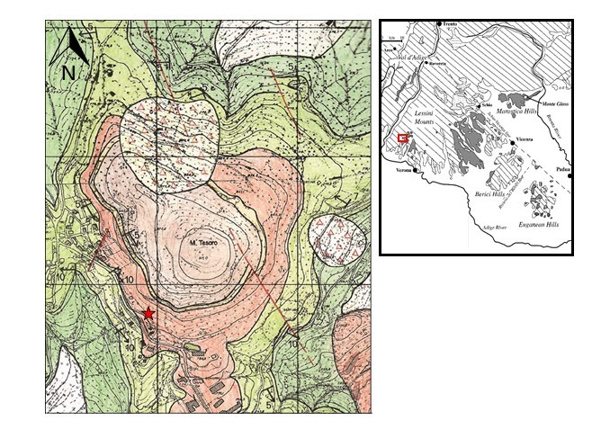
Figure 1 Geological map of the area (Cipriani, 1997). The approximate location of the volcanic outcrop where the Mt1 apatite crystal was found is also shown. Dark green: Biancone/Maiolica (Cenomanian-Turonian); light green: Scaglia Rossa (Turonian - Maastrichtian), Orange: extradiatremic volcanoclastic (Eocene); Light yellow: Scaglia Cinerea (Lower Eocene); Brown: Calcari Nummulitici (Eocene).
GPS location of outcrop: 45°35'40.3"N 10°57'37.6"E, SP12 37020 Sant'Anna D'Alfaedo Verona, Italy
Figure 2. Images of Mt1 apatite. a) Optical image b)-d) Backscatter Scanning Electron Microscope (BSEM) pictures of late melt percolations and mineral segregation in veinlets/fractures of MT1 apatite.
Da spostare leggermente inset in Fig 2D

Figure 3. Backscatter Scanning Electron Microscope (BSEM) pictures of late melt percolations and mineral segregation in veinlets/fractures of MT1 apatite.

Fig. 4. Results of the Rietveld refinement of the Mt1 apatite in the selected region 10-100 °2θ. Legend: crosses = observed pattern; single line = calculated pattern. The curve of the difference between the observed and calculated profiles and markers relative to the diffraction peaks of the two phases are also shown.

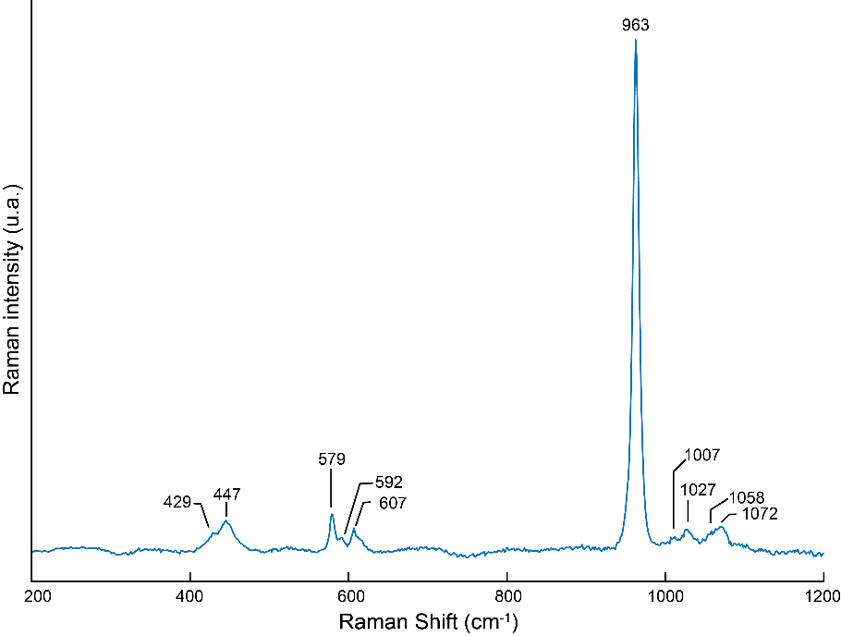

Figure 5. Raman spectra of the MT1 apatite.
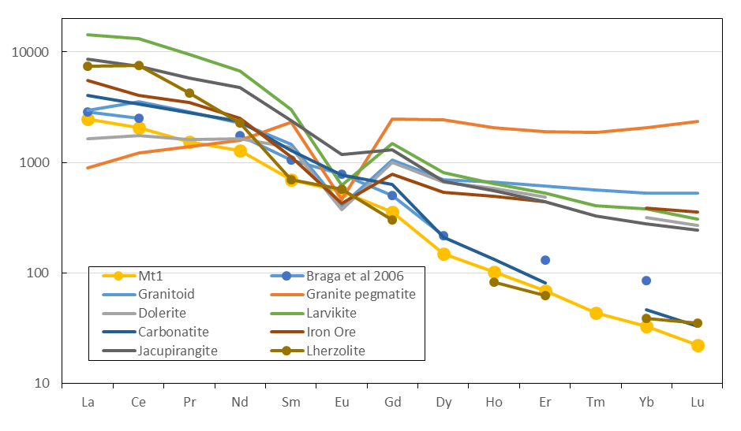
Figure 6. Chondrite C1-normalized rare earth element (REE) pattern of MT1 apatite compared to the apatite of Braga et al 2006 from the Veneto Volcanic Province. C1-normalizing values are from McDonough and Sun (1995). Data of apatites from other rock types are from Belousova et al (2002).

*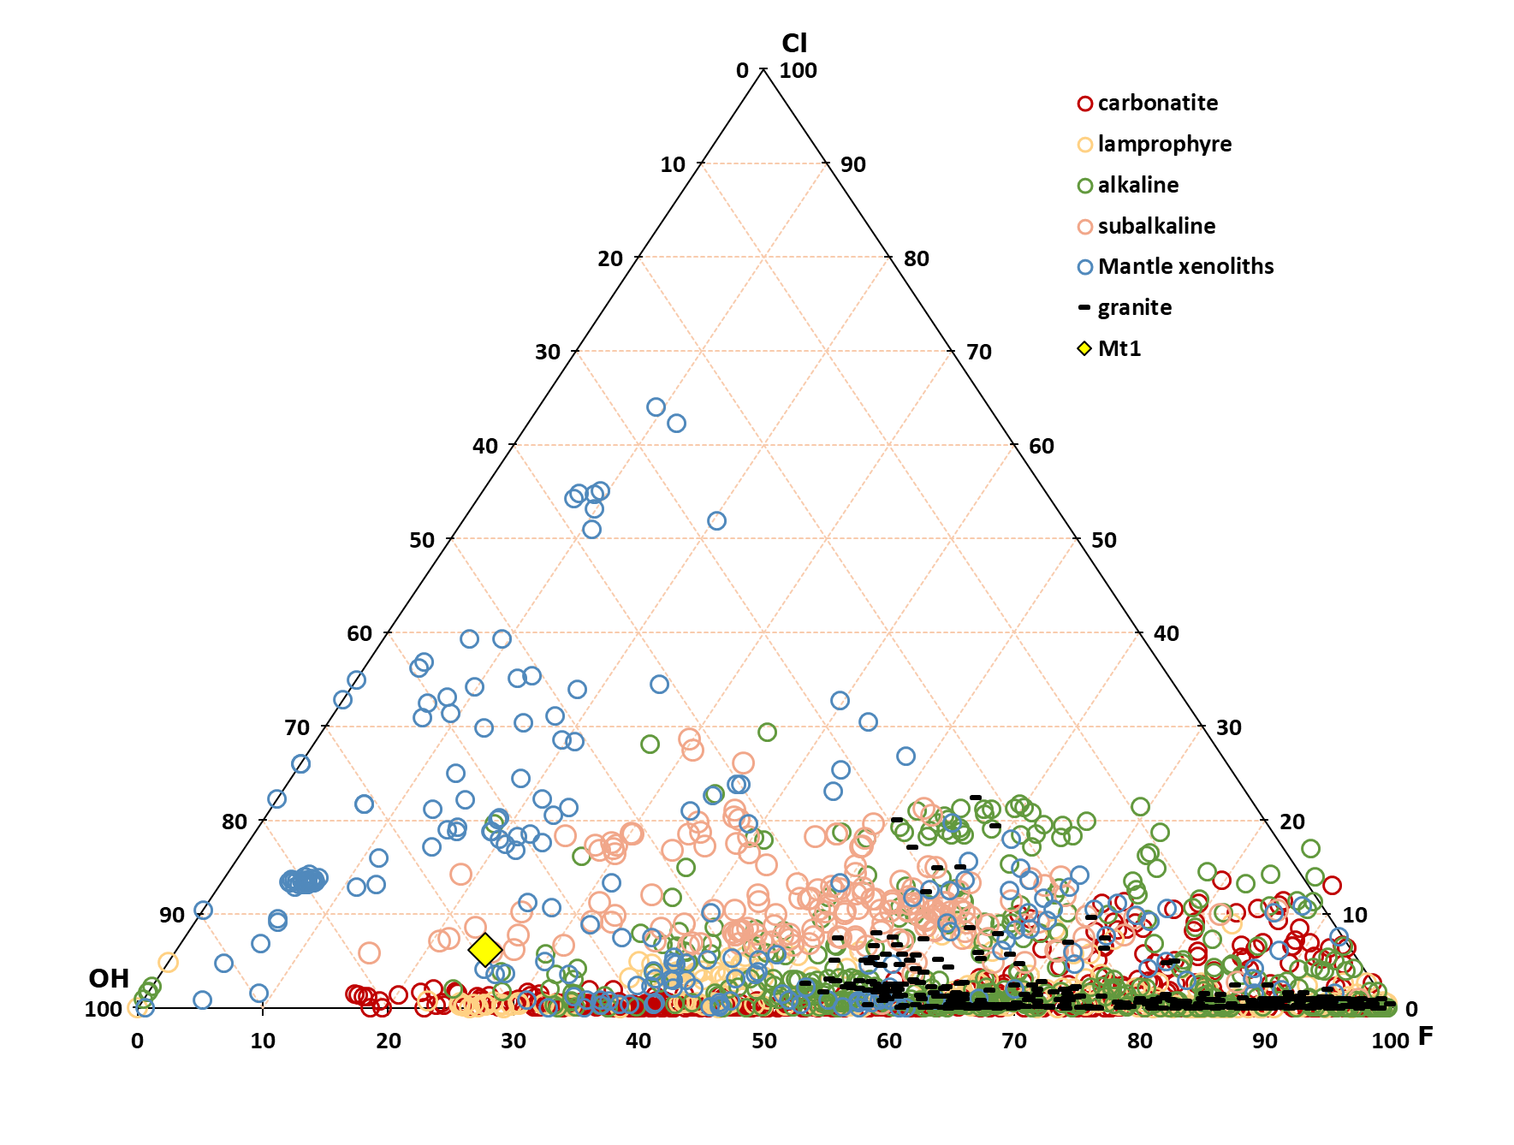
Fig. 7. Ternary plot of Mt1 apatite X-site occupancy (mole %) and comparison to apatite from different lithologies (georoc.org)

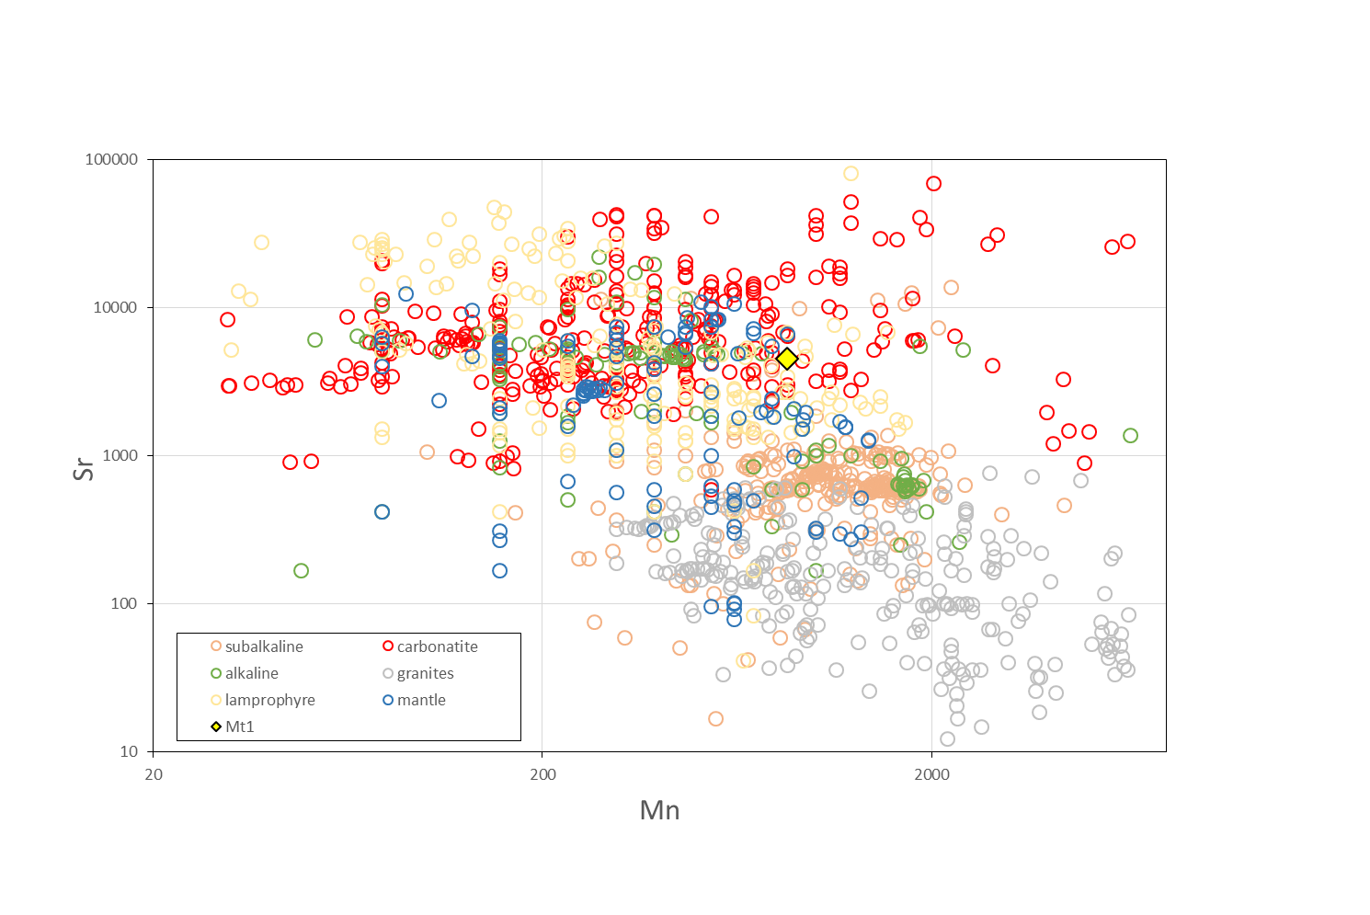
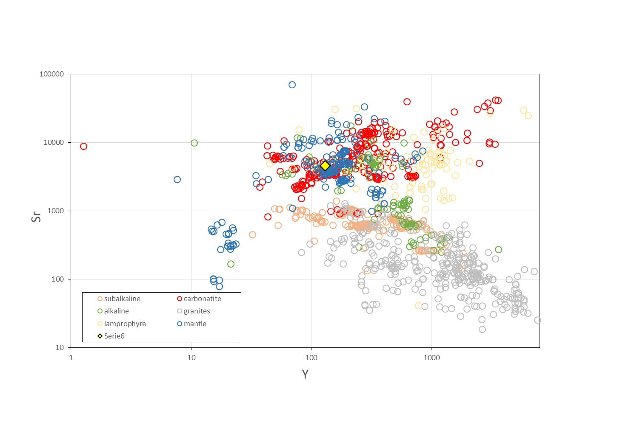
Fig 8a-b. Sr vs Mn and Sr vs Y of apatites from different lithologies (Georoc.org)

Figure 9. Sr and Nd isotope composition of Mt1 apatite and lavas and xenoliths from the VVP (Beccaluva et al. 2007; Macera et al., 2003; Gasperini et al., 2006)

Fig 10. Ch-normalized REE for calculated melts of various composition at equilibrium with Mt1 apatite.
Fig 11. Ch-normalized REE patterns of volcanics from the VVP (Georoc.org)

Table 2. Major element data of Mt1 Apatite

Table 3. Major element data of secondary mineral phases to add Mg#

Table 4. Trace element data of Mt1 apatite

Table 5. Sr and Nd isotope data of Mt1 apatite

