r_{i}
α
r_{o}
Δ
P
P

α
p

α
F
β
M₀
N₀
r_{g}
(a) (b)

Figure 1. (a) Pin-lug connection, (b) the lug is simplified as a partial ring of constant section.

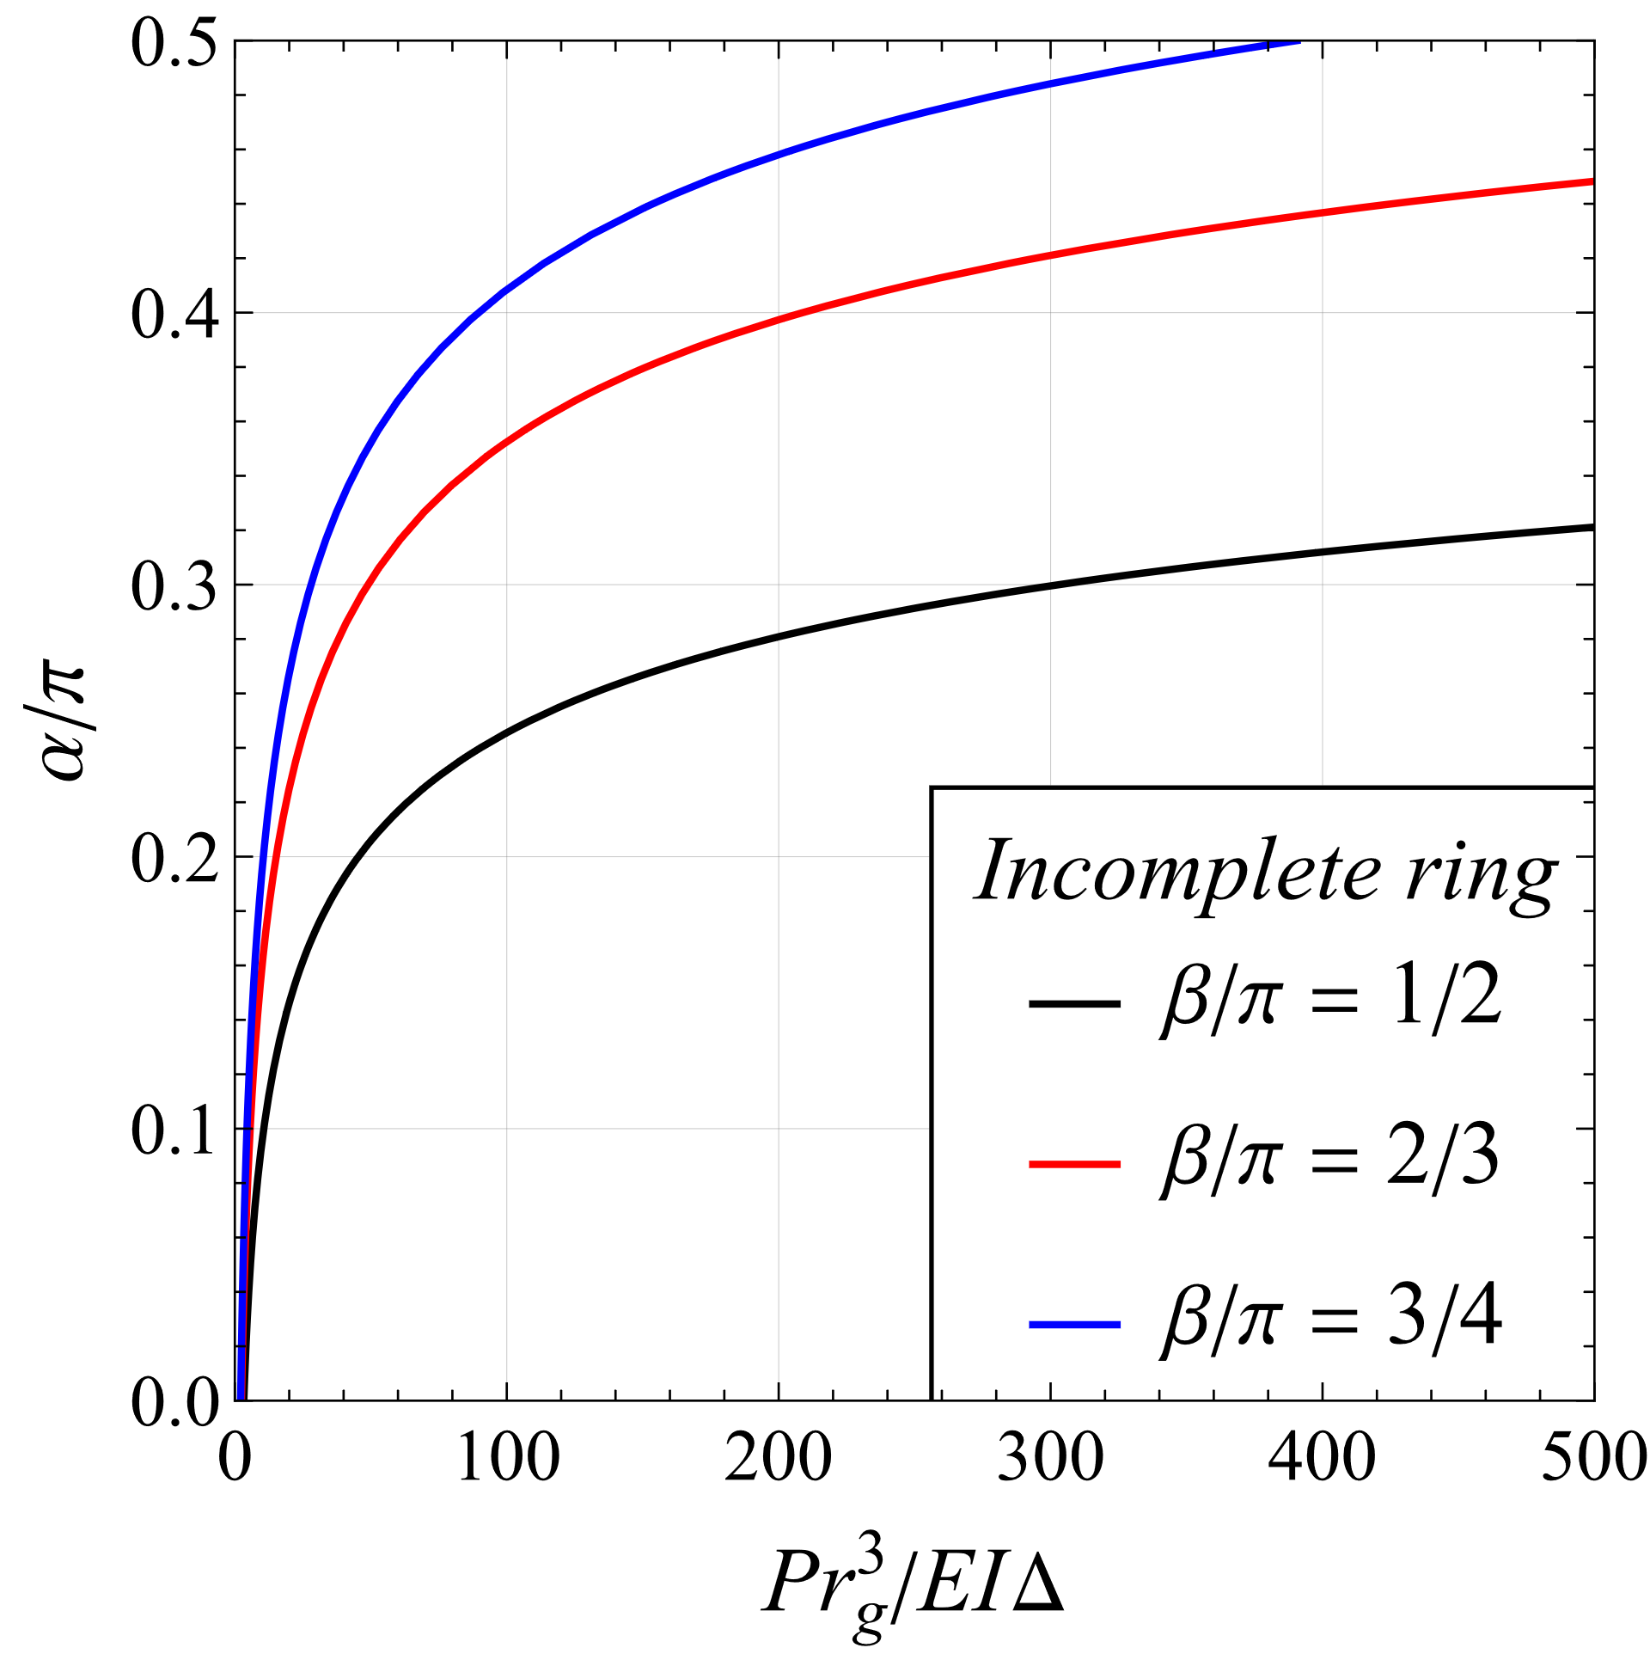

Figure 2. Half contact angular extent α/π versus the enhanced load factor Ψ for the analytical lug model expressed in terms of an incomplete ring.

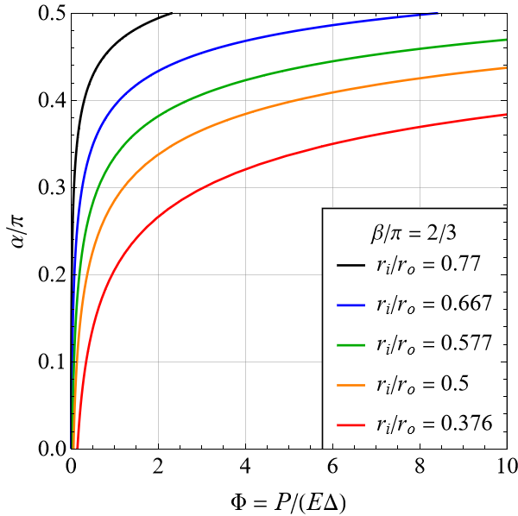

Figure 3. Half contact angular extent α/π versus the load factor Φ for the analytical lug model expressed in terms of a partial ring.

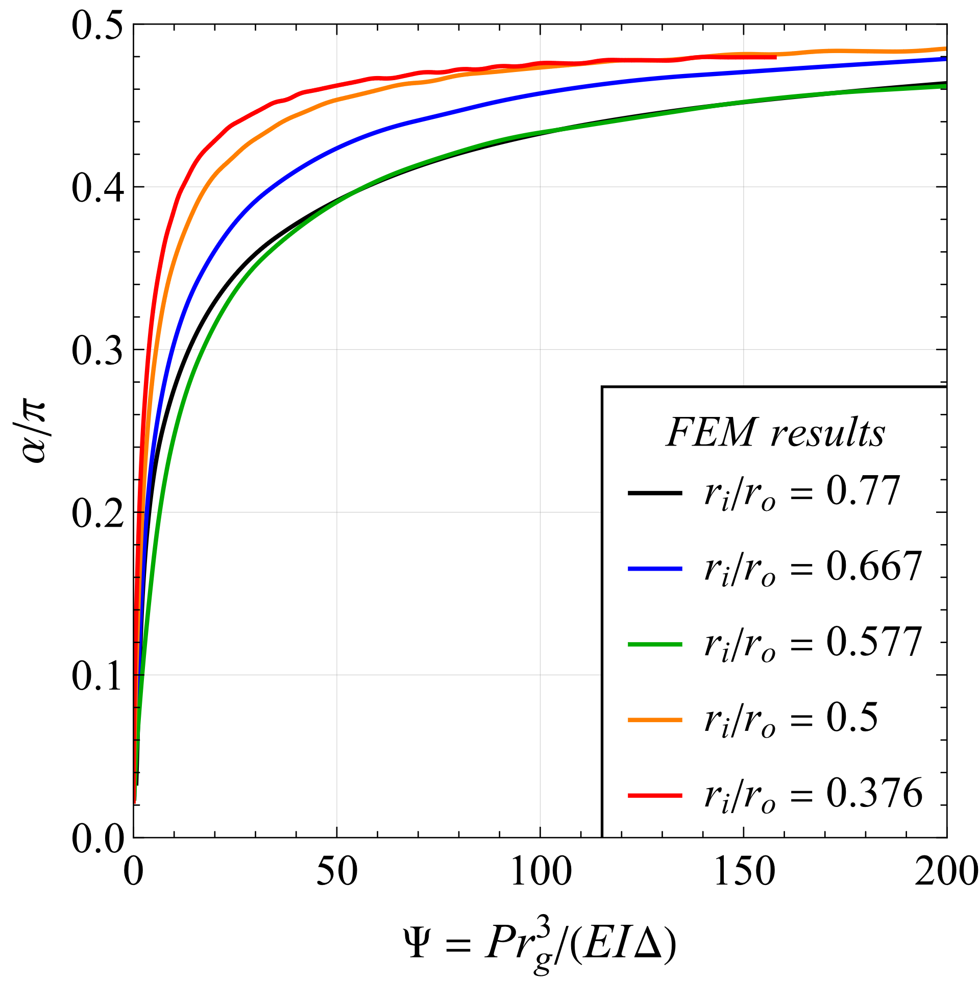

Figure 4. The FE predictions of the half contact angle α/π versus the enhanced load factor Ψ, for a selection of aspect ratios δ.

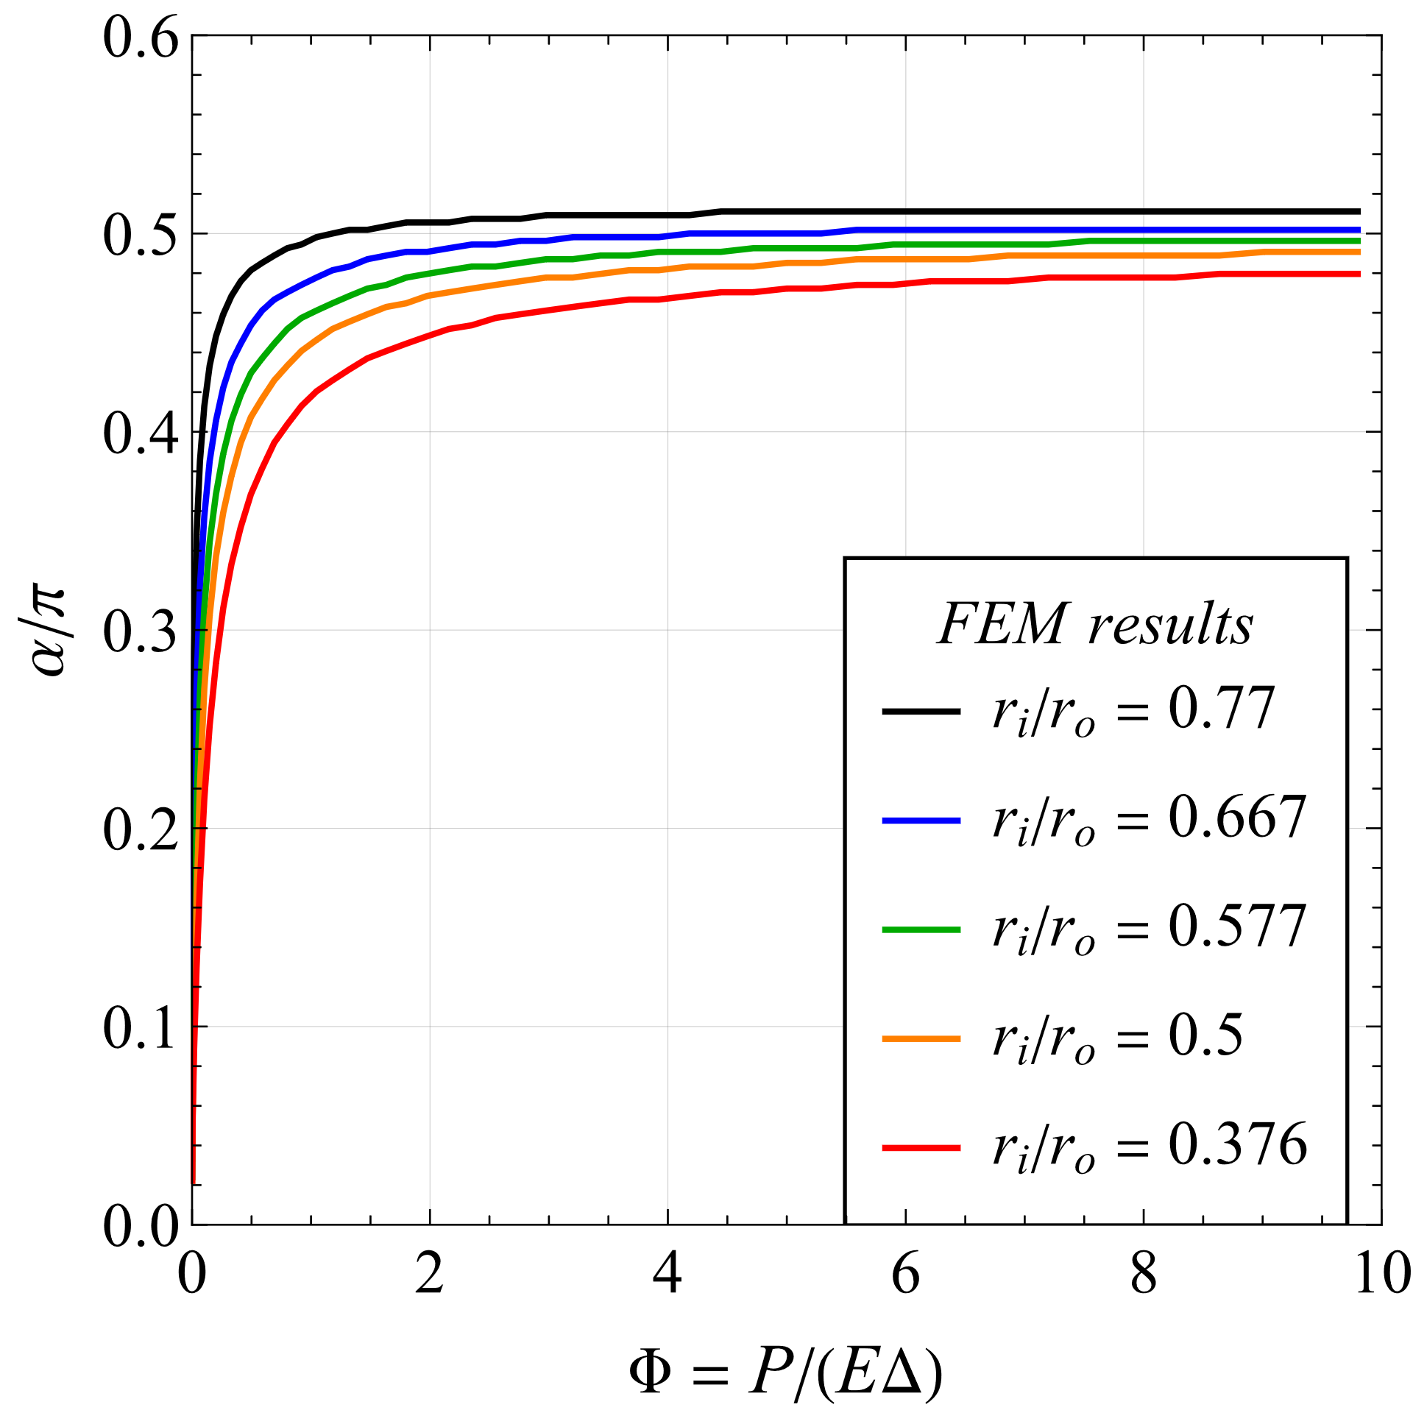

Figure 5. The FE prediction on the half contact angle α/π, versus the load factor Φ, for a selection of δ=r_{i}/r_{o} aspect ratios.

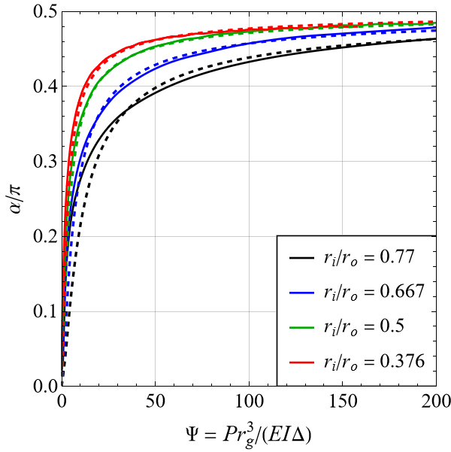

Figure 6. Comparison between the half contact angular extent α forecast by the FEM analysis (solid lines) and the approximated values obtained from eqn (15) (dashed lines) for four values of δ=r_{i}/r_{o}.

